
All about me

My full name is_________________________________________

I would like to be known as
____________________________________________

Here is a picture/photograph of me

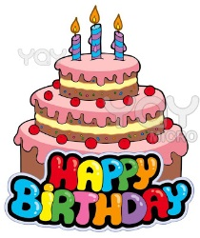
I am _________________ years old

My birthday is on _______________________________________
I can draw a picture of my family

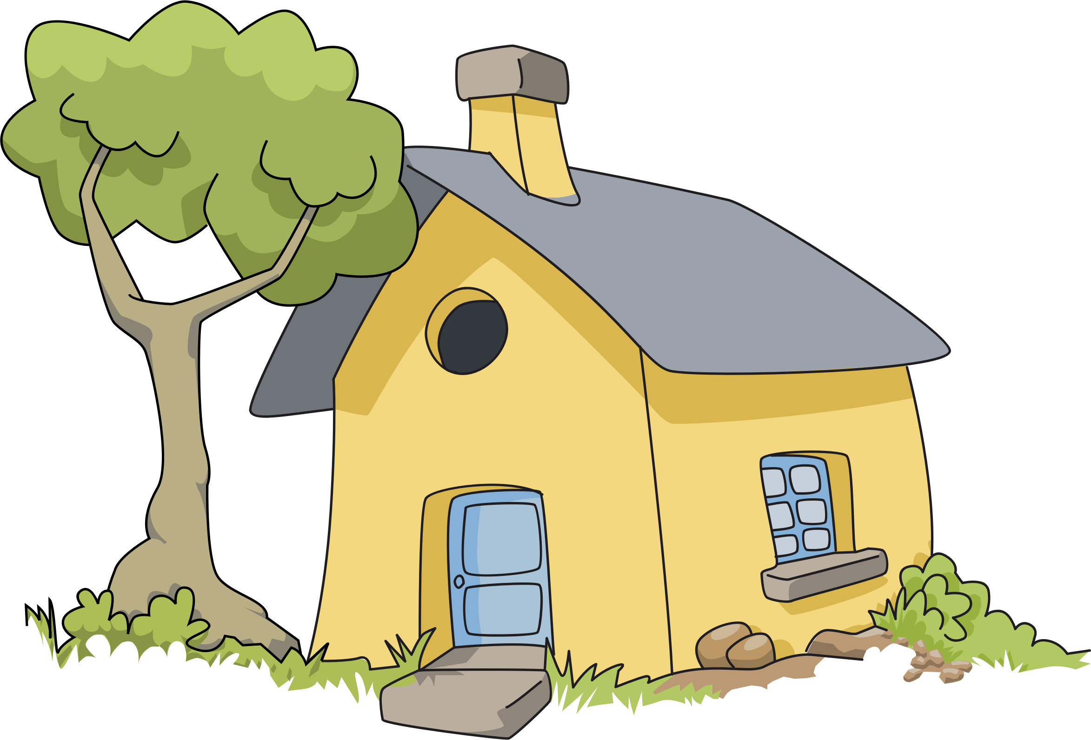
My favourite things
Friends and family who are important to me are:-

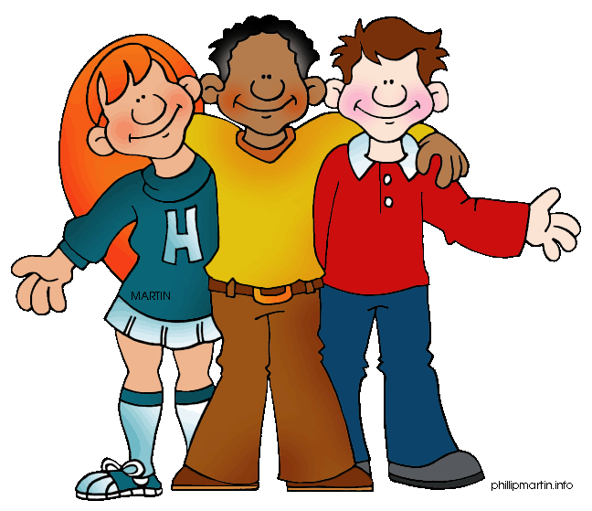

Who lives in your house with you?

The main language we speak at home is:-

Things I like to do are………..

My favourite song/rhyme is…



My favourite book is……….


My favourite television programme is ……….



My favourite toy is……….

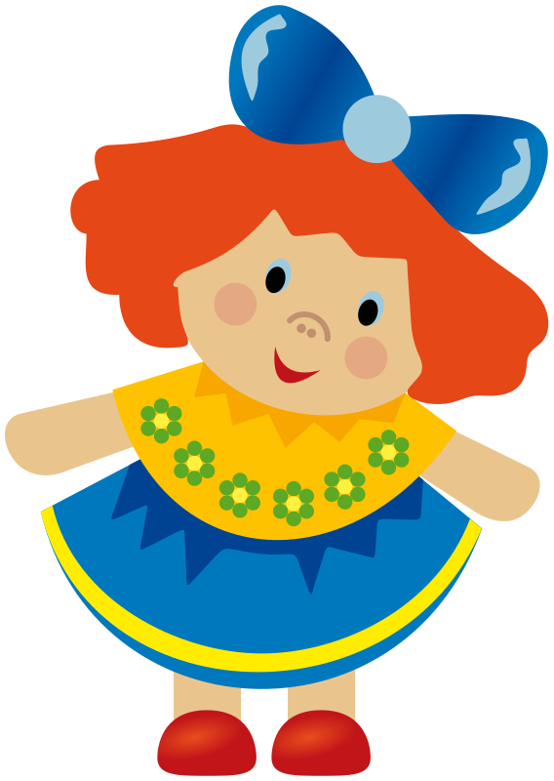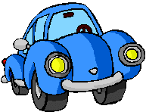
My favourite game is……….

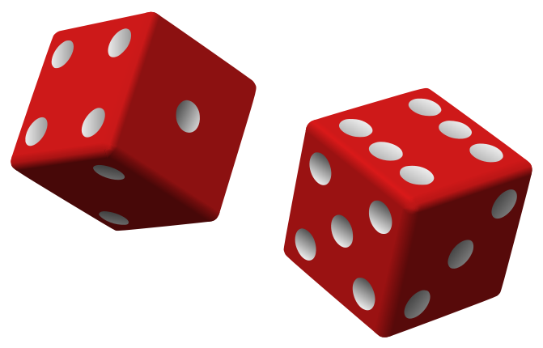
I like to drink ……….


I like to eat……….


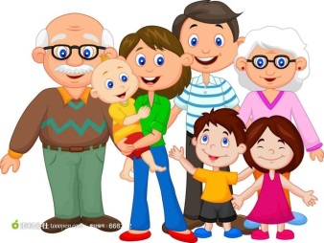
Parents’/Carers’ Pages

My child has allergies, medical conditions or takes regular medication Yes/No (if yes please tell us what they are)

My child can’t eat or drink e.g. non-halal meat, orange juice

My child sleeps well: usually sometimes never

Does your child have any other problems or is there anything you are worried about? (You can talk to us if you don’t want to write it down)

Please give the following information if relevant:

My child has/has not previously attended playgroup/nursery/child-minder
If they have please list below:

______________________________________________________

My child is shy when_____________________________________

______________________________________________________

My child finds it difficult to_________________________________

______________________________________________________

My child is confident when_________________________________

______________________________________________________

My child gets upset/frightened when_________________________

______________________________________________________

Is there anything else you would like to tell us about your child/family?

