EAD-
They safely use and explore a variety of materials, tools and techniques, experimenting with colour, design, texture, form and function. (Art Link)
To move along to the beat of a familiar song.
(Music Link)
To describe ways of safely using and exploring a variety of materials. (DT/Art Link)
Selects tools and techniques needed to shape, assemble and join materials they are using.
(DT/Art Link)
To clap rhythmic patterns
To understand that pictures represent different clapping patterns)

Maths-
children recognising that a shape can have other shapes within it. Children will begin by using two shapes to make a new shape. They will build on this composition of shapes skill to attempt building one shape in multiple ways. Partitioning numbers has been introduced previously. This unit will allow children to see that shapes can also be ‘partitioned’ in multiple ways.
children will meet, for the first time, volume and capacity. They will learn how to compare two or more items using the vocabulary of measure and will begin to compare containers visually. Link to Key Stage 1
children will sort up to 5 objects into two or more groups using the size, colour or shape characteristics of the items being sorted.

F2 Summer 2 skills and knowledge
Physical-
To show good control and co-ordination in large and small movements. (Computing Link)
To know how to handle a range of equipment and tools effectively
To know how to use scissors effectively.

PSE-
To be able to give facts about a specified subject.
To know different life cycles.
To know a range of facts.
To engage in meaningful conversations with others.

UOW-
To understand how vegetables are grown
Plant and care for own vegetables
Sort fruit and vegetables
To explore unfamiliar vegetables.
Talk about the job of the roots
Know the difference between root and sprout.
I can ask questions about their familiar world (where they live or the natural world).(Geography Link)
To select appropriate materials according to their properties.
(Science Link)
To begin to understand that things change over time.
(Science/ Geography Link)
To begin to understand that things happened a really long time ago.
(History Link)
To know the job of a farmer
To name the animals found on a farm Exploring a range of habitats, looking at why the animal lives like that.
(Science Link)
Create maps of a farm (Geography Link)

Literacy-
To think of and write a short, simple sentence.
Listening to and hearing sounds in CVC and CVCC words.
Identifying sounds, including phonemes and other digraphs on a sound mat. (Su2)
Checking written work and making any changes where necessary.
Knowing the sounds that the taught phonemes make.
Knowing what the taught phonemes look like.
Knowing how to write the taught letters.
Recognising taught HFW in text.
To know that a sentence starts with a capital letter and ends with a full stop. (Su2)
Knowing that sentences can be extended by using a connective.
Uses learnt words and phrases to discuss familiar stories or during role play.

C&L-
To label and sort living things.
To begin to research using a search engine.
To describe habitats.
To name and sort a range of living things.
To be able to talk about different habitats.
To engage in meaningful conversations with others.

Curriculum- What we will do……
Theme  Transport/Farms |  | 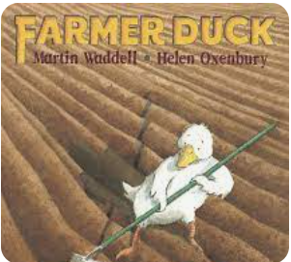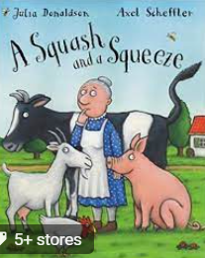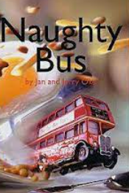 |  |  |  | Important Dates/Weeks
Role Play |  | Farmers House, Bus |  |  |  | Trips: Farm- Tam O’ Shanter, Church Farm
P.S.E | Physical development |  | Communication and Language/Literacy | Maths | Understanding the world |  | Expressive arts
Talk about the affects of the environment for farmers  Effects of the natural world on farmers- rain fall, floods, drought | Using a comfortable pencil grip to form letters correctly.  Moving around, under, over and through the outdoor equipment safely  Using all equipment inside appropriately making sure all is stored correctly. |  | Learn a story off by heart to perform  Change the characters in the story.  Write a simple story  Write a fact sheet about the animals | Power Maths Summer 2 | To look at the importance of public transport now and then  Look at how transport has change and sequence  Look at the importance of farmers.  To name farm animals and describe their habitats  Know what animals produce  Difference between farm animals and zoo animals  Look at where eggs come from

