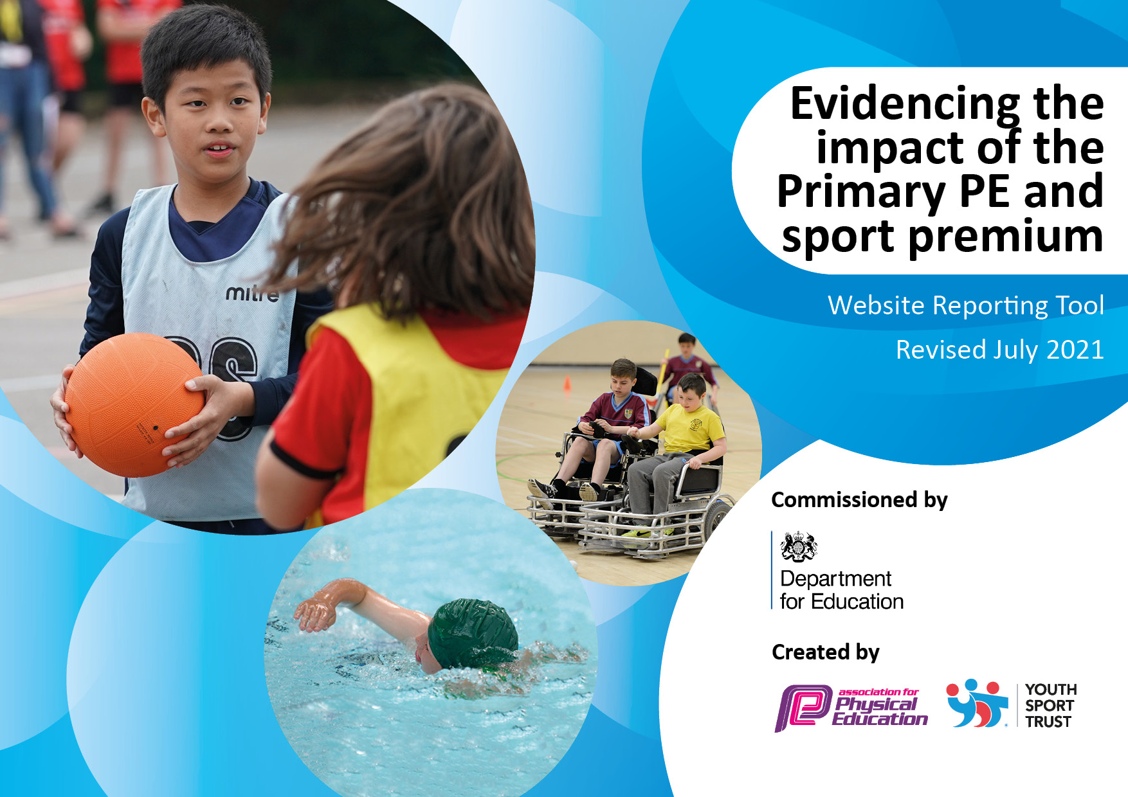
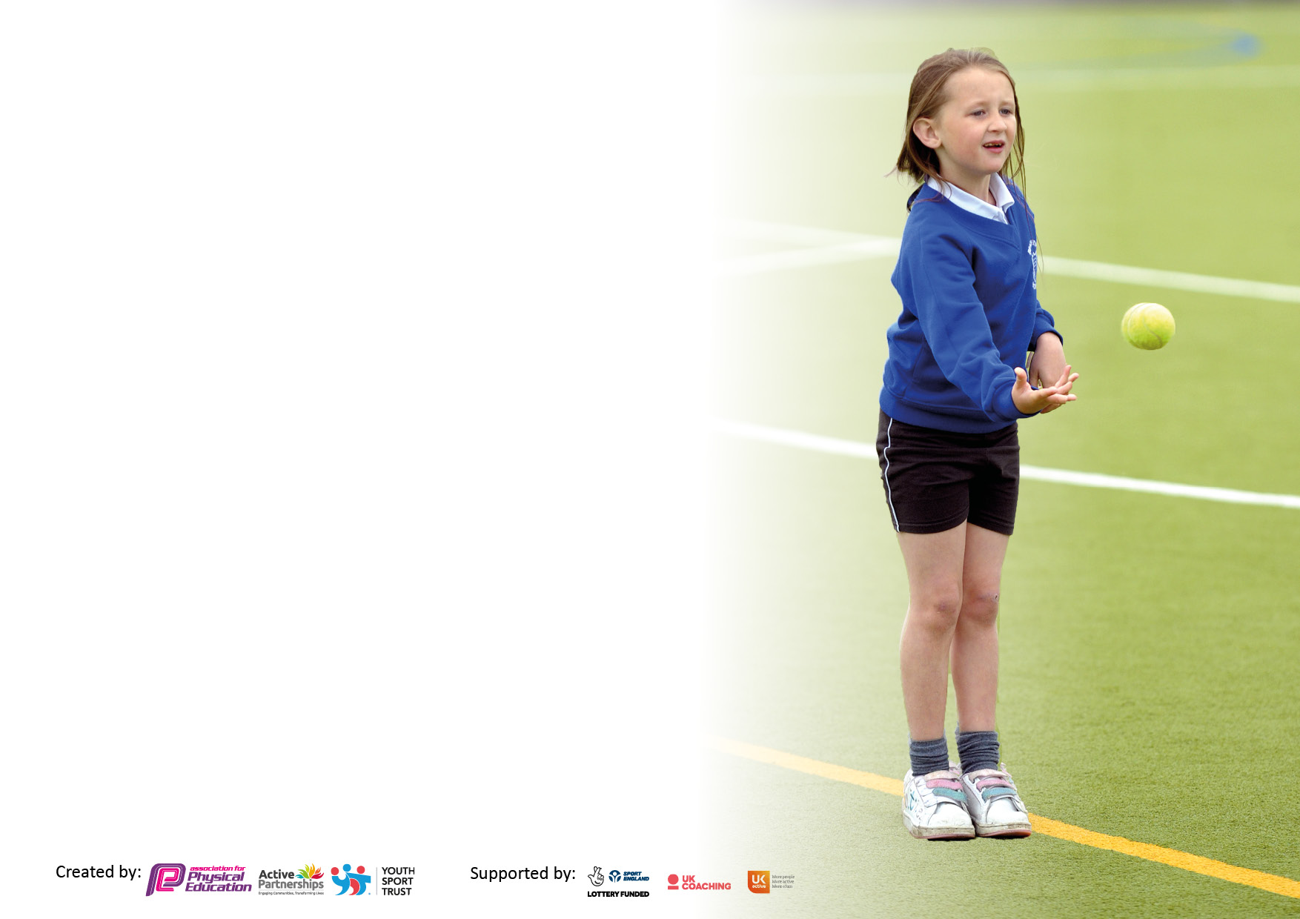

It is important that your grant is used effectively and based on school need. The Education Inspection Framework makes clear there will be a focus on ‘whether leaders and those responsible for governors all understand their respective roles and perform these in a way that enhances the effectiveness of the school’.

Under the Quality of Education Ofsted inspectors consider:
Intent - Curriculum design, coverage and appropriateness
Implementation - Curriculum delivery, Teaching (pedagogy) and Assessment
Impact - Attainment and progress

To assist schools with common transferable language this template has been developed to utilise the same three headings which should make your plans easily transferable between working documents.

Schools must use the funding to make additional and sustainable improvements to the quality of Physical Education, School Sport and Physical Activity (PESSPA) they offer. This means that you should use the Primary PE and sport premium to:

- Develop or add to the PESSPA activities that your school already offer
- Build capacity and capability within the school to ensure that improvements made now will benefit pupils joining the school in future years
- The Primary PE and sport premium should not be used to fund capital spend projects; the school’s budget should fund these.

Pleasevisitgov.ukfortherevisedDfEguidanceincludingthe5keyindicatorsacrosswhichschoolsshoulddemonstrate animprovement.Thisdocumentwillhelpyoutoreviewyourprovisionandtoreportyourspend.DfEencouragesschools to use this template as an effective way of meeting the reporting requirements of the Primary PE and sport premium.

We recommend you start by reflecting on the impact of current provision and reviewing the previous spend.

Schools are required to publish details of how they spend this funding, including any under-spend from 2019/2020, as well as on the impact it has on pupils’ PE and sport participation and attainment. All funding must be spent by 31st July 2022.

We recommend regularly updating the table and publishing it on your website throughout the year. This evidences your ongoing self-evaluation of how you are using the funding to secure maximum, sustainable impact. Final copy must be posted on your website by the end of the academic year and no later than the 31st July 2021. To see an example of how to complete the table please click HERE.
Created by: Supported by:

Details with regard to funding
Please complete the table below.

Total amount carried over from 2019/20 | £0
Total amount allocated for 2020/21 | £17615
How much (if any) do you intend to carry over from this total fund into 2021/22? | £7685
Total amount allocated for 2021/22 | £17565
Total amount of funding for 2021/22. To be spent and reported on by 31st July 2022. | £25250
Swimming Data
Please report on your Swimming Data below.

Meeting national curriculum requirements for swimming and water safety.

N.B. Complete this section to your best ability. For example you might have practised safe self-rescue techniques on dry land which you can then transfer to the pool when school swimming restarts.
Due to exceptional circumstances priority should be given to ensuring that pupils can perform safe self rescue even if they do not fully meet the first two requirements of the NC programme of study
What percentage of your current Year 6 cohort swim competently, confidently and proficiently over a distance of at least 25 metres? | 78%
What percentage of your current Year 6 cohort use a range of strokes effectively [for example, front crawl, backstroke and breaststroke]?  Please see note above | 75%
What percentage of your current Year 6 cohort perform safe self-rescue in different water-based situations? | 75%
Schools can choose to use the Primary PE and sport premium to provide additional provision for swimming but this must be for activity over and above the national curriculum requirements. Have you used it in this way? | Yes/No

Action Plan and Budget Tracking
Capture your intended annual spend against the 5 key indicators. Clarify the success criteria and evidence of impact that you intend to measure to evaluate for pupils today and for the future.

Academic Year: 2020/21 | Total fund allocated: | Date Updated:
Key indicator 1: The engagement of all pupils in regular physical activity – Chief Medical Officers guidelines recommend that primary school pupils undertake at least 30 minutes of physical activity a day in school |  |  |  | Percentage of total allocation:
 |  |  |  | %
Intent | Implementation |  | Impact
Your school focus should be clear what you want the pupils to know and be able to do and about  what they need to learn and to  consolidate through practice: | Make sure your actions to achieve are linked to your intentions: | Funding allocated: | Evidence of impact: what do pupils now know and what can they now do? What has changed?: | Sustainability and suggested next steps:
Enhance the provision of swimming in KS2  Additional swimming to enhance curriculum achievement  Improve current school sports equipment  Improve breadth of PE curriculum  Improve mental. Health within our pupils, through active learning and play.  Provide children with OAA curriculum through residential stays | -Children in Y5 to swim on a weekly basis to aim towards target of 25m unassisted at the end of Y6  -4 weeks (2 x 2 weeks) of sessions intensive session for Year 4 to improve water confidence and safety  -Invest in additional sports equipment to provide more opportunities for activities at break and lunchtime, and to provide equipment for all lessons, despite covid restrictions  -12 hours of Archery Coaching for Year 6.  Body Roller (ordered July 2022)  Liquid floor tiles (ordered July 2022)  Contribution towards Year 5 residential to Brathay Hall (subsidy to total cost).  Contribution towards Year 5 residential to Brathay Hall (staff cover)  Contribution towards Year 5 residential to Brathay Hall (staff expenses).  Contribution towards Year 3 residential to Brathay Hall (staff cover) | £3002  £790  £1018.06  £600  £595  £120  £705  £743  £100  £455 | 75% of July 2022 Year 5 met national curriculum standard.  24 children had an additional 2 week swimming in 2021  More equipment for PE lessons meaning that during Covid restrictions all children could still continue to have PE lessons with equipment, whilst adhering to school risk assessment.  Enough equipment for play and lunch times for each class bubble so we the bubbles do not share equipment, in line with our school risk assessment.  24 children received 12 hours of specialist archery coaching.  To provide our children with daily sensory circuits sessions from September 2022.  21 children went on the residential. | Change model for next year to 20 daily swims in 2, 2 week blocks.  With relaxation on covid rules, use additional equipment to supplement future lessons by having individual skill learning.  Continue to provide Archery in June 2023  Make sensory circuits a regular part of the timetable with feedback from pupils.  Look for residentials closer to home to save on transport cost.
Key indicator 2: The profile of PESSPA being raised across the school as a tool for whole school improvement |  |  |  | Percentage of total allocation:
 |  |  |  | %
Intent | Implementation |  | Impact
Your school focus should be clear what you want the pupils to know and be able to do and about  what they need to learn and to  consolidate through practice: | Make sure your actions to achieve are linked to your intentions: | Funding allocated: | Evidence of impact: what do pupils now know and what can they now do? What has changed?: | Sustainability and suggested next steps:
Provide daily interventions for children based around mental health through physical activity.  Add physical activity opportunities in curriculum time.  Provide Outdoor learning opportunities for cross curricular active learning, and break/lunch time play, | Pay for a member of staff to run daily ‘sensory circuits’ for pupils to improve mental health and well-being.  Subscription to “Maths of the Day”  Playground markings for learning (to be installed over Summer 2022) | £1182.87  £545  £2525.60 | 35 children have accessed these sessions since September 2021-July 22  All children receive 1 hour of Active maths lessons per week.  All children in school from September to access an additional 30 mins of active learning per week. | Make sensory circuits a regular part of the timetable with feedback from pupils.  Use Active maths at least twice a week.  Provide up to 30 mins a week of active learning.

Key indicator 3: Increased confidence, knowledge and skills of all staff in teaching PE and sport |  |  |  | Percentage of total allocation:
 |  |  |  | %
Intent | Implementation |  | Impact
Your school focus should be clear | Make sure your actions to | Funding | Evidence of impact: what do | Sustainability and suggested
what you want the pupils to know | achieve are linked to your | allocated: | pupils now know and what | next steps:
and be able to do and about | intentions: |  | can they now do? What has
what they need to learn and to |  |  | changed?:
consolidate through practice:
Enhance the teaching of PE throughout each Key Stage  Increasing opportunities for physical activity at break and lunch times  Improve provision of swimming teaching | Invest in subscription for Edsential Scheme of Work  Daily active break and lunch times  Training and supply cover for 1 teacher to go on 2-day Teaching swimming course | £240  £1183.86  £456 | All children receiving high quality PE with clear progression based on the scheme of work.  Daily activities for all children at break and lunchtimes to increase physical activity. Training provided for 36 children in Year 5 and 6 to act as playleaders to run games and activities.  Smaller groups during swim lessons to improve provision. | Use scheme of work to prepare PE long term plan  Use playleaders to provide competitive experiences for all children.
Key indicator 4: Broader experience of a range of sports and activities offered to all pupils |  |  |  | Percentage of total allocation:
Intent | Implementation |  | Impact
Your school focus should be clear | Make sure your actions to | Funding | Evidence of impact: what do | Sustainability and suggested
what you want the pupils to know | achieve are linked to your | allocated: | pupils now know and what | next steps:
and be able to do and about | intentions: |  | can they now do? What has
what they need to learn and to |  |  | changed?:
consolidate through practice:
Enhance the opportunities for extra-curricular sport clubs | External providers contacted and delivering a variety of sports clubs:  -Sally Williams (Flickers & Fliers)  -Football (Graham Branch)  -Fencing (Wayne Lomax)  Internal provider  -Multi Sports clubs for KS1 KS2 (MMc) | £760  £1200  £750  £7148.75 | 90% of children from F1 to Year 6 children accessed 6 hours of trampolining coaching.  Provided 122 children with 6 hours of football coaching.  14 different clubs including football, tag rugby, circuits, gymnastics, fencing etc. 92% of children from F2-Y6 accessed 6 hours or more of these clubs. | Continue to offer trampolining next year.  Target 8% who have not taken part in 2022/23

Key indicator 5: Increased participation in competitive sport |  |  |  | Percentage of total allocation:
 |  |  |  | %
Intent | Implementation |  | Impact
Your school focus should be clear | Make sure your actions to | Funding | Evidence of impact: what do | Sustainability and suggested
what you want the pupils to know | achieve are linked to your | allocated: | pupils now know and what | next steps:
and be able to do and about | intentions: |  | can they now do? What has
what they need to learn and to |  |  | changed?
consolidate through practice:
Give at least 1 opportunity for every pupil at St. Josephs to take part in a level 2 sports event, festival or residential.  Provide a competitive sports day for Year 3-6 for 100% of children to take part in a Level 1 event.  Provide resources for children to be able to enter competitions | Provide cover and transport for Sport’s competition  Medals for competing.  New Sports kit (Ordered July 2022) | £694.32  £81  £750 | 90% of children from Year 1 to Year 6 took part in a level 2 sports event, festival or residential.  99% of children from Year 3-6 took part in a competitive sports day.  To provide our children additional competitive opportunities in September 2022-July 2023 | Target 10% who have not taken part in 2022-23  Continue to offer sports days in 2023  Enter multiple teams into tournaments.
Total Spend September 2021-July 2022: £25045 (£205 remaining)

Signed off by
Head Teacher: | 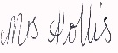  Mrs M Hollis
Date: | 21.07.2022
Subject Leader: | M. McGovern
Date: | 18.7.2022
Governor: | Mr B Sharp
Date: | 21.07.2022

