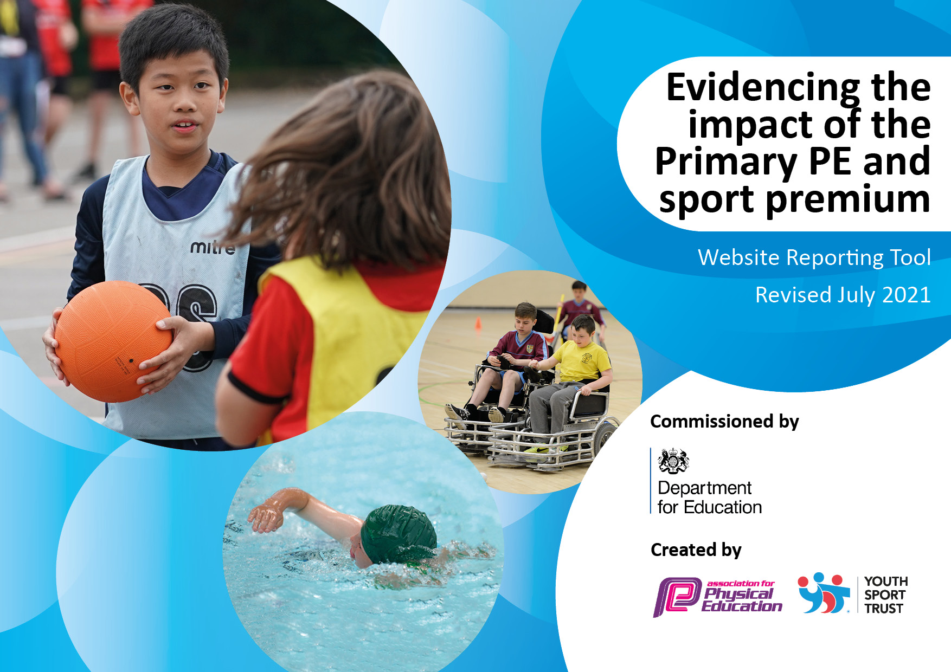
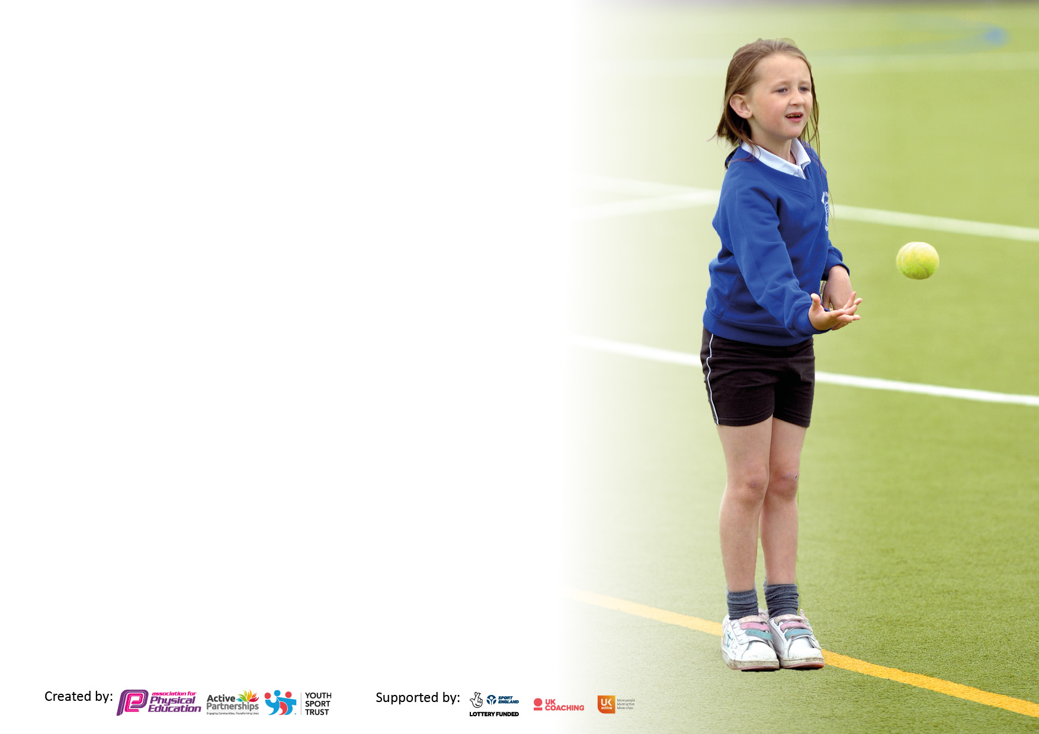

It is important that your grant is used effectively and based on school need. The Education Inspection Framework makes clear there will be a focus on ‘whether leaders and those responsible for governors all understand their respective roles and perform these in a way that enhances the effectiveness of the school’.

Under the Quality of Education Ofsted inspectors consider:
Intent - Curriculum design, coverage and appropriateness
Implementation - Curriculum delivery, Teaching (pedagogy) and Assessment
Impact - Attainment and progress

To assist schools with common transferable language this template has been developed to utilise the same three headings which should make your plans easily transferable between working documents.

Schools must use the funding to make additional and sustainable improvements to the quality of Physical Education, School Sport and Physical Activity (PESSPA) they offer. This means that you should use the Primary PE and sport premium to:

- Develop or add to the PESSPA activities that your school already offer
- Build capacity and capability within the school to ensure that improvements made now will benefit pupils joining the school in future years
- The Primary PE and sport premium should not be used to fund capital spend projects; the school’s budget should fund these.

Pleasevisitgov.ukfortherevisedDfEguidanceincludingthe5keyindicatorsacrosswhichschoolsshoulddemonstrate animprovement.Thisdocumentwillhelpyoutoreviewyourprovisionandtoreportyourspend.DfEencouragesschools to use this template as an effective way of meeting the reporting requirements of the Primary PE and sport premium.

We recommend you start by reflecting on the impact of current provision and reviewing the previous spend.

Schools are required to publish details of how they spend this funding, including any under-spend from 2019/2020, as well as on the impact it has on pupils’ PE and sport participation and attainment. All funding must be spent by 31st July 2022.

We recommend regularly updating the table and publishing it on your website throughout the year. This evidences your ongoing self-evaluation of how you are using the funding to secure maximum, sustainable impact. Final copy must be posted on your website by the end of the academic year and no later than the 31st July 2021. To see an example of how to complete the table please click HERE.


Created by: Supported by:

Details with regard to funding
Please complete the table below.

Total amount carried over from 2023/24 | £11062
Total amount allocated for 2023/24 | £17541
How much (if any) do you intend to carry over from this total fund into 2024/25 | £28603
Total amount allocated for 2024/25
Swimming Data
Please report on your Swimming Data below.

Meeting national curriculum requirements for swimming and water safety.

N.B. Complete this section to your best ability. For example you might have practised safe self-rescue techniques on dry land which you can then transfer to the pool when school swimming restarts.
Due to exceptional circumstances priority should be given to ensuring that pupils can perform safe self rescue even if they do not fully meet the first two requirements of the NC programme of study
What percentage of your current Year 6 cohort swim competently, confidently and proficiently over a distance of at least 25 metres? | 35%
What percentage of your current Year 6 cohort use a range of strokes effectively [for example, front crawl, backstroke and breaststroke]?  Please see note above | 35%
What percentage of your current Year 6 cohort perform safe self-rescue in different water-based situations? | 50%
Schools can choose to use the Primary PE and sport premium to provide additional provision for swimming but this must be for activity over and above the national curriculum requirements. Have you used it in this way? | Yes/No

Action Plan and Budget Tracking
Capture your intended annual spend against the 5 key indicators. Clarify the success criteria and evidence of impact that you intend to measure to evaluate for pupils today and for the future.

Academic Year: 2023/24 | Total fund allocated:£17451 + carry over of £11062=£28603 | Date Updated: Aug 2024
Key indicator 1: The engagement of all pupils in regular physical activity – Chief Medical Officers guidelines recommend that primary school pupils undertake at least 30 minutes of physical activity a day in school |  |  |  | Percentage of total allocation:
 |  |  |  | %
Intent | Implementation |  | Impact
Your school focus should be clear what you want the pupils to know and be able to do and about  what they need to learn and to  consolidate through practice: | Make sure your actions to achieve are linked to your intentions: | Funding allocated: | Evidence of impact: what do pupils now know and what can they now do? What has changed?: | Sustainability and suggested next steps:
Improve mental. Health within our pupils, through active learning and play.  Improve provision of swimming in national curriculum  Improve the provision of PE curriculum in Early Years  Increase the breadth of active curriculum in Foundation stage  Provide residential opportunities in Year 5  Provide an active dance music workshop to support mental health | 36 weeks of Sensory circuit sessions,2 x a week  Additional swimming sessions for Year 5  Early Years trampolining 5 weeks x 3 sessions  Balance bikes  Tricycles  Balancing and riding equipment  Ride on cars  Early Years ground work  Playground balls  Chanel and cascade water play  Subsidised cost of residential  RockKidz active dance workshop | £2509  £840  £528  £475  £169  £1200  £244  £7000  £39  £199  £360  £689 | Provided 18 children with sensory circuits sessions  Additional swimming for 24 children.  60 children receiving additional trampolining. | Allocate time table for additional children to do sensory circuits.  Make sensory circuits a regular part of the timetable with feedback from pupils.
Key indicator 2: The profile of PESSPA being raised across the school as a tool for whole school improvement |  |  |  | Percentage of total allocation:
 |  |  |  | %
Intent | Implementation |  | Impact
Your school focus should be clear what you want the pupils to know and be able to do and about  what they need to learn and to  consolidate through practice: | Make sure your actions to achieve are linked to your intentions: | Funding allocated: | Evidence of impact: what do pupils now know and what can they now do? What has changed?: | Sustainability and suggested next steps:

Key indicator 3: Increased confidence, knowledge and skills of all staff in teaching PE and sport |  |  |  | Percentage of total allocation:
 |  |  |  | %
Intent | Implementation |  | Impact
Your school focus should be clear | Make sure your actions to | Funding | Evidence of impact: what do | Sustainability and suggested
what you want the pupils to know | achieve are linked to your | allocated: | pupils now know and what | next steps:
and be able to do and about | intentions: |  | can they now do? What has
what they need to learn and to |  |  | changed?:
consolidate through practice:
Enhance the teaching of PE throughout each Key Stage | Invest in subscription for Edsential Scheme of Work | £350 | All children receiving high quality PE with clear progression based on the scheme of work. | Use scheme of work to prepare PE long term plan
Key indicator 4: Broader experience of a range of sports and activities offered to all pupils |  |  |  | Percentage of total allocation:
Intent | Implementation |  | Impact
Your school focus should be clear | Make sure your actions to | Funding | Evidence of impact: what do | Sustainability and suggested
what you want the pupils to know | achieve are linked to your | allocated: | pupils now know and what | next steps:
and be able to do and about | intentions: |  | can they now do? What has
what they need to learn and to |  |  | changed?:
consolidate through practice:
Enhance the opportunities for extra-curricular sport clubs | External providers contacted and delivering a variety of sports clubs:  Flickers & Fliers (Cheerleading)  Internal provider  -Tennis  -Dance | £350  £180  £360 | 99% participation in Extra curricular provision when combined with clubs ran through Extending School’s facilities fund. | Continue to offer trampolining next year.  Continue to offer clubs next year

Key indicator 5: Increased participation in competitive sport |  |  |  | Percentage of total allocation:
 |  |  |  | %
Intent | Implementation |  | Impact
Your school focus should be clear | Make sure your actions to | Funding | Evidence of impact: what do | Sustainability and suggested
what you want the pupils to know | achieve are linked to your | allocated: | pupils now know and what | next steps:
and be able to do and about | intentions: |  | can they now do? What has
what they need to learn and to |  |  | changed?
consolidate through practice:
Provide a competitive sports day for Year 3-6 for 100% of children to take part in a Level 1 event.  Provide additional opportunities for sports competitions | Medals for competing.  Transport to events  Supply claimed by Sports lead for competitions | £270  £588  £4058 | 99% of children from Year 3-6 took part in a competitive sports day.  4 competitions entered with 35 children taking part  dance festival performances with 40 children taking part
Total Spend Sep 2023-Aug 24: £20408 (Carry forward £8195)

Signed off by
Head Teacher: | 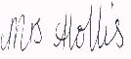  Mrs M Hollis
Date: | 01/04.24
Subject Leader: | M. McGovern
Date: | 01/04/24
Governor: | Mr B Sharp
Date: | 01/04/24

