[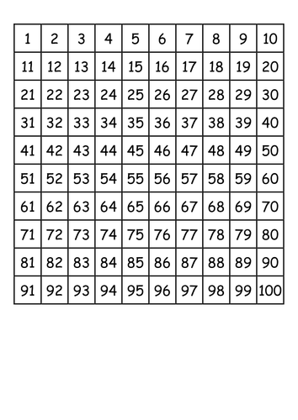](https://www.google.co.uk/url?sa=i&url=https://www.pinterest.com/pin/335096028515295710/&psig=AOvVaw10o2vwzPweswyIo_Pl4lOm&ust=1585743272848000&source=images&cd=vfe&ved=0CAIQjRxqFwoTCNDG2ZXYxOgCFQAAAAAdAAAAABAI)