Welcome to St Josephs’ Foundation Stage.  Whether this is your eldest child or you are used to the school way of life, starting school is a very big step, both for you and your child. A happy start is very important.  You are your child’s first and best teacher and by learning from you, school and home will be able to work together, forming a lasting partnership of quality, which will help to ensure that your child’s learning continues to be as successful in school as it has been at home.  At St Joseph’s we pride ourselves on our caring family atmosphere where each child is nurtured and valued. Please make sure that any concerns are brought to our attention. Remember that we are here for the parents too. This booklet should hopefully answer any immediate questions.  Snack time and drinks  Children will be encouraged to eat free fruit and will be able to have free school milk until their 5th birthday. Also your will child need to bring a water bottle (water only please,) daily, which they can access when required. Please let us know of any food allergies.  . |  | Toilet Time  We have our own toilets next to the classroom which the children can access at any time.  Please prepare your child for school by encouraging them to take care of their own hygiene. They should be able to wipe themselves and wash hands independently. Please also put some spare underwear in your child’s PE bag in case of accidents. It is quite normal for any child to have occasional accident, we don’t make a fuss. |  | 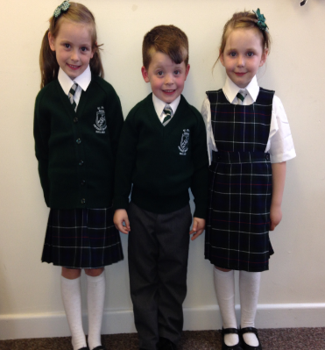

Starting school

at

St Joseph’s Catholic Primary School

 |  | The school day  Your child can arrive at school from 8.45 onwards where a member of staff will be on hand to supervise in the playground. You can stay with your child until 8:55 when the whistle will go and your child will line up. Please use this time to speak to your child’s teacher if you wish. When the whistle blows you may help your child into school if they are at all fretful (this is quite normal in a new environment). You may stay until you feel your child is settled. We will ring you if we are at all concerned. Your child will be ready to leave school at 3.15. Please collect them from the classroom. |  | “We provide your child with the tools for a life long love of reading”
Reading and Homework  Reading is a very important skill and at St Joseph’s we provide your child with the tools for a life-long love of reading.  Each child will be given a reading book which is changed after your child has read it. You can read with your child and make comments in the diary provided. The book is intended to help practice skills learnt in class and will be monitored regularly for suitability.  Homework will also be given out weekly which will reflect the work the children have been learning that week.  Lunch Times  At St Joseph’s we provide our own in house catering. We use all fresh products and have a 3 week menu cycle- sample available. School dinners are free for every child. If your child stays for lunch please fill out the relevant dinner form.  If you do not wish your child to have a school lunch, please provide a labelled lunchbox containing a reasonable amount of food that they will eat (we do encourage them to eat it all.)  All our children eat together and it is lovely to see them using table manners that you have taught them at home. They will be supervised and if they do not eat some of their food, we will let you know, but unfortunately we are unable to offer alternatives. |  |  |  | Uniform  Girls- White shirt, school tie, green knitted cardigan with the badge and school tartan kilt or pinafore dress. Other type of skirts are not permitted.  Boys- White shirt, school tie, bottle green knitted jumper with the school badge and grey school trousers.  Blazer- A school blazer with the school bade is optional.  Footwear- Sensible black shoes must be worn. Trainers, sandals or boots are not permitted.  P.E Kit- black shorts, white round neck t shirt with school badge and black pumps.  The school day  8.45- Gates open. Teachers will be at the door to greet the children. Please make sure you bring your child right to the door.  10.15- Snack time  11.40- Lunchtime. Half an hour in the dinner hall, half an hour in the playground.  11.45- Home time for 2 and 3 year olds  2.15- Snack: fruit and water  3.00- Home time for 4 yr olds. Collect the children from the same door.
Keyworkers
Most of you will be familiar with what a key worker is, as all Early Years Educators now operate this system. A key worker helps ensure that every child’s learning and care is tailored to meet his/her individual needs. Key workers spend time as a small group with their children. You will be told who your child’s key worker is in September.

Religious Education

