[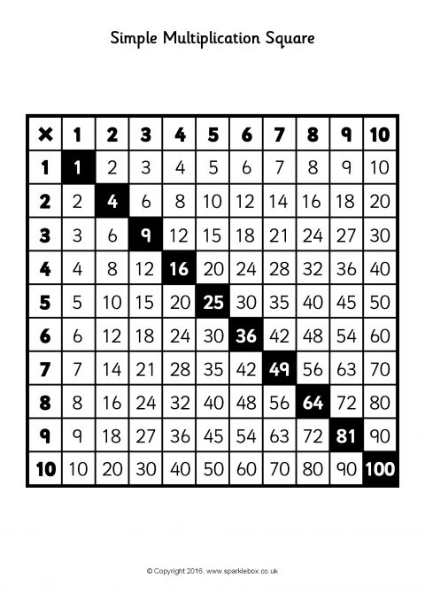](https://www.google.co.uk/url?sa=i&url=https://www.sparklebox.co.uk/previews/11726-11750/sb11741-simple-multiplication-squares.html&psig=AOvVaw2E1pkAL9JY2yAixAF0boHp&ust=1585743435956000&source=images&cd=vfe&ved=0CAIQjRxqFwoTCJDjmObYxOgCFQAAAAAdAAAAABAD)