Weekly attendance newsletter – Week 3 Autumn term 2 2022-2023
As a school, we aim for all children to have 95% or above attendance.
From September until this week, our overall school attendance is 89.9%
Last week, our overall school attendance was 87.4% (counting children at or above mandatory school age = 5).
STRIVE FOR 95+%
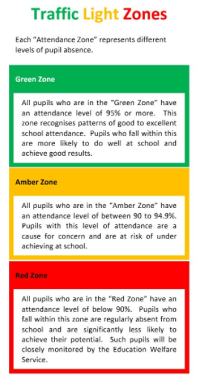
The best place for your children to be every day is in school.
 | Last week | Two weeks ago
2-year-olds | 85.7% | 80.5%
F1 | 98.3% | 80.6%
F2 | 87.7% | 83.7%
Y1 | 89.6% | 87.9%
Y2 | 92.7% | 91.5%
Y3 | 80.8% | 85.4%
Y4 | 84.1% | 80%
Y5 | 85.4% | 84.6%
Y6 | 91.8% | 90%

