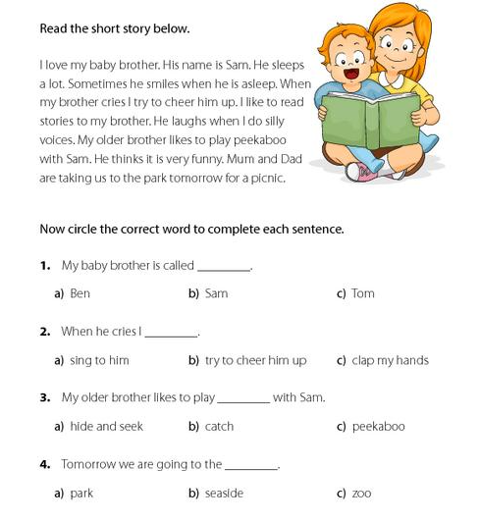
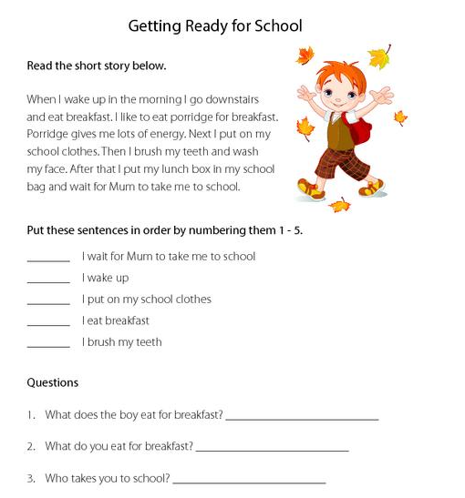
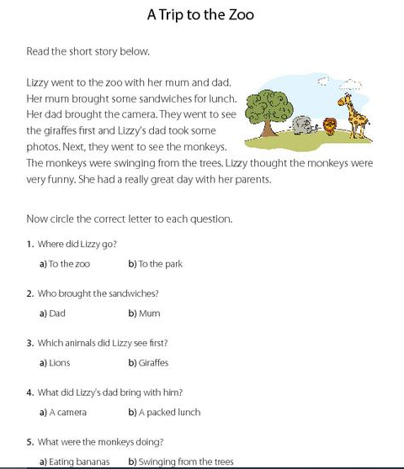
Answers

My Baby Brother
- b – Sam
- b – try to cheer him up
- c – peekaboo
- a - park

Getting ready for school
5
1
3
2
4

1) porridge

A trip to the zoo
- a - to the zoo
- b – mum
- b – giraffes
- a – camera
- b – swinging from the trees

