Literacy-
To think of and write a short, simple sentence.
Listening to and hearing sounds in CVC and CVCC words.
Identifying sounds, including phonemes and other digraphs on a sound mat.
Listens to stories and is beginning to anticipate what may happen next.
Knowing the sounds that the taught phonemes make.
Knowing what the taught phonemes look like.
(Knowing how to write the taught letters.
Recognising taught HFW in text.
To know that a sentence starts with a capital letter and ends with a full stop.
Knows how to spell some familiar words.

Maths-
children will continue exploring subtraction, now looking specifically at the number bonds to 10. These are shown using counters and the part-whole model, which have both been used before. Children will begin to work with subtraction number bonds, following the ‘missing part’ structure.

children will be encouraged to recognise, extend, create and explain simple repeating patterns. They will consider patterns not just in pictures but in their everyday environment and using sounds, words and actions.

F2 Spring 2 skills and knowledge
Physical-
To show good practice with regard to exercise, eating, sleeping and hygiene.
To be able to balance and coordinate safely.
To negotiate space effectively.
To know how good practice with regard to exercise, eating sleeping and hygiene can contribute to good health.
To know how to use scissors effectively.

PSE-
To talk about similiariteis and differences
To understand that people have different beliefs and traditions.
To understand we are all made in the image and likeness of God.
To talk about the effect my behaviour has on others

UOW-
To know that some foods are unhealthy. Sorting healthy and unhealthy foods. (Science Link)
To know the names of common fruits and vegetables. (Science Link)
To identify and sort healthy/unhealthy foods.(Science Link)
To identify and group a range of fruits and vegetables.(Science Link)
To talk about a special event in their life. (History Link)
Know that their own experiences differ to those of others.
(Sp1/2)
(History Link)
I can talk about features of my own immediate environment and how environments may vary from one another
(Science/ Geography Link)
To know that Christians celebrate Easter. (RE Link)
To know that there are many countries around the world.(Geography Link)
To know that other countries have a different climate.(Geography Link)
To know that different countries have different cultures.(Geography Link)
To find a different country on a world map.(Geography Link)
Identify similarities and difference between life in a different country.(Geography Link)

EAD-
To use a range of resources to create own props to aid role play.(DT/Art Link)
To plan, carry out and evaluate and change where necessary. (DT Link)
Manipulates materials to achieve a planned effect. (DT/Art Link)
To effectively use instruments to tap a simple beat. (Music Link)
To use a range of props to support and enhance role play. (DT/Art Link)
To identify and select resources and tools to achieve a particular outcome.(DT Link)
To be able to play instruments along to a simple beat.
(Music Link)
To know how to use our body to show high and low sounds
To explore how to use voice to create high and low sounds
To draw a range of plants and fruits .(Art Link)

C&L-

To talk about the role of healthy food and exercise in staying healthy.
To know different traditional stories.
To know a range of healthy food and exercise.

Curriculum- What we will do……
Theme  Our World |  | 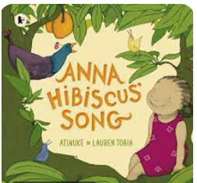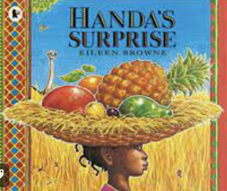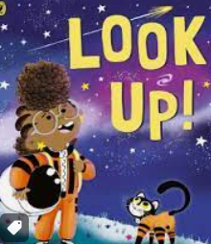 |  |  |  | Important days/weeks  Panto, French week, Fathers Day, World Ocean Day
Role Play |  | Fruit shop, Rocket |  |  |  | Trips: Walk to the fruit man/Eureka/ Imagine That
P.S.E | Physical development |  | Communication and Language/Literacy | Maths | Understanding the world | Expressive arts
Look at different cultures and understand how are all loved by God  Talk about what makes us happy- special events in their lives  How we can make others happy  What we aspire to be when we grow up.  Role models and inspirations. | Cutting using knives safety  Understand the effects of exercise  Be able to talk about heart rate and exercise.  Use fine motor skills to create necklaces, |  | Write shopping lists for Anna and Handa  Instructions for the fruit salad.  Sequence the story  Think of an alternative ending  Change the story  Learn and use new vocabulary. | Power Maths Summer 1 | To find Africa on the world map  To find similarities in Annas country  Differences from Annas country  Look at a mango tree, what other fruits grow on trees.  Make a fruit salad  Sort healthy and un healthy food and the effects on the body  Rocket girl looks down from space to find France- French week  Begin planting- for new life ready for Summer 1.

