Weekly attendance newsletter – Week 4 Spring Term 2 2022-2023
As a school, we aim for all children to have 100% attendance.
From September until this week, our overall school attendance is 90.7%
Last week, our overall school attendance was 89.3 % (counting children at or above mandatory school age = 5).
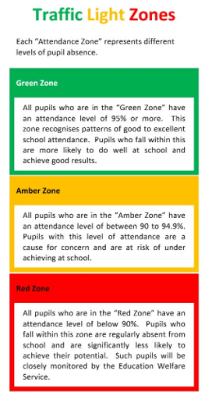
STRIVE FOR 100%
The best place for your children to be every day is in school.
 | Last week | Two weeks ago
2-year-olds | 61.4% | 82.1%
F1 | 70.2% | 85.5%
F2 | 92% | 78.7%
Y1 | 90.6% | 92.1%
Y2 | 90.7% | 95.5%
Y3 | 93.1% | 87.5%
Y4 | 98% | 92%
Y5 | 85.6% | 93.2%
Y6 | 75.4% | 92.4%

