Weekly attendance newsletter – Week 6 Autumn term 1 2022-2023
As a school, we aim for all children to have 95% or above attendance.
From September until this week, our overall school attendance is 90.8%
Last week, our overall school attendance was 90% (counting children at or above mandatory school age = 5).
STRIVE FOR 95+%
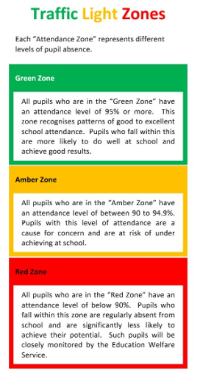
The best place for your children to be every day is in school.
 | Last week | 2 weeks ago
2-year-olds | 65% | 81.3%
F1 | 55.4% | 86.2%
F2 | 97.2% | 89.3%
Y1 | 83.8% | 88.8%
Y2 | 100% | 78.5%
Y3 | 86.2% | 82.7%
Y4 | 92.6% | 95.2%
Y5 | 85.7% | 87.8%
Y6 | 84.3% | 84.3%

