1. 3 + 4 =
Key Stage 1 Arithmetic Assessment
Addition and subtraction within 10
2. 8 – 0 =
3. 7 – 1 =
4. 5 + 5 =
5. 2 + 8 =
6. 6 – 2 =
7. 2 + 2 =
8. 2 + 3 =
9. 4 + 6 =
10. 8 – 3 =
11. 10 – 4 =
12. 1 + 6 =
13. 0 + 7 =
14. 5 – 4 =
15. 4 + 4 =
16. 9 - 5 =
17. 5 + 2 =
18. 3 + 7 =
19. 10 – 1 =
20. 7 – 4 =

1. 12 + 4 =
Key Stage 1 Arithmetic Assessment
Addition and subtraction not crossing 10s
2. 16 – 3 =
3. 11 + 4 =
4. 39 + 1 =
5. 19 – 6 =
6. 14 – 0 =
7. 25 + 3 =
8. 19 – 4 =
9. 14 – 3 =
10. 18 + 2 =
11. 50 – 1 =
12. 17 + 0 =
13. 16 + 4 =
14. 13 + 6 =
15. 13 – 1 =
16. 18 – 4 =
17. 31 + 4 =
18. 28 – 1 =
19. 13 + 7 =
20. 17 – 5 =
1. 10 x 3 =
Key Stage 1 Arithmetic Assessment
Counting in 2s, 5s and 10s and Finding ½ and ¼ of a number
2. 5 x 2 =
3. 2 x 4 =
4. 2 x 3 =
5. 5 x 4 =
6. 10 x 7 =
7. 2 x 8 =
8. 5 x 6 =
9. 10 x 4 =
10. 2 x 1 =
11. ½ of 4 =
12. ½ of 16 =
13. ¼ of 4 =
14. ¼ of 20 =
15. ½ of 14 =
16. ¼ of 24 =
17. ½ of 2 =
18. ¼ of 12 =
19. ½ of 6 =
20. ½ of 22 =
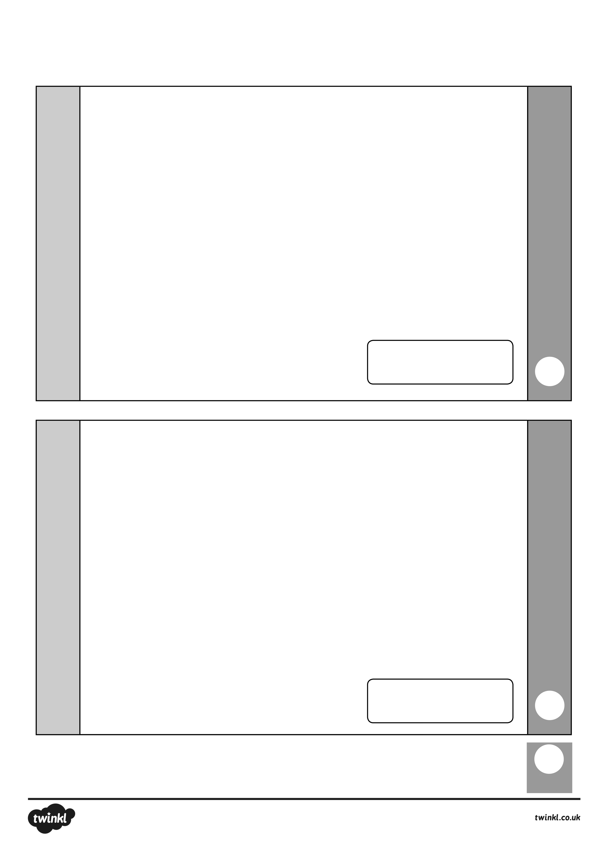
total
mark
mark
6 + 6 =
9 + 3 =
2
1
Key Stage 1 Arithmetic Assessment
Addition and Subtraction crossing 10s
mark
mark
total
9 + 6 =
8 + 5 =
4
3
Key Stage 1 Arithmetic Assessment
Title
total
mark
mark
5
6
8 + 9 =
4 + 7 =
Key Stage 1 Arithmetic Assessment
Title
Answers
Key Stage 1 Arithmetic Assessment
Title

Page 1
1. 7
2. 8
3. 6
4. 10
5. 10
6. 4
7. 4
8. 5
9. 10
10. 5

Page 2
1. 16
2. 13
3. 15
4. 40
5. 13
6. 14
7. 28
8. 15
9. 11
10.20

11. 6
12. 7
13. 7
14. 1
15. 8
16. 4
17. 7
18. 10
19. 9
20. 3

11. 49
12. 17
13. 20
14. 19
15. 12
16. 14
17. 35
18. 27
19. 20
20. 12
Answers
Key Stage 1 Arithmetic Assessment
Title

Page 3
1. 30
2. 10
3. 8
4. 6
5. 20
6. 70
7. 16
8. 30
9. 40
10. 2

Page 4 – 6
1. 12
2. 12
3. 13
4. 15
5. 17
6. 11

11. 2
12. 8
13. 1
14. 5
15. 7
16. 6
17. 1
18. 3
19. 3
20. 11

