**Weekly attendance newsletter – Week 5 Summer 1 2022-2023**

We strive for every pupil to be present for every day that school requires a child to attend.

From September until this week, our overall school attendance is **90.7%**

Last week, our overall school attendance was **90.2%** (counting children at or above mandatory school age = 5).

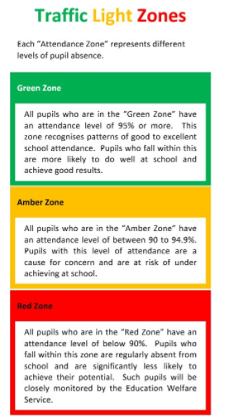STRIVE FOR 100%

**The best place for your children to be every day is in school.**

|  |  |  |
| --- | --- | --- |
|  | **Last week** | **Two weeks ago** |
| 2-year-olds | 85.7% | 76.8% |
| F1 | 79% | 66.3% |
| F2 | 93% | 91.6% |
| Y1 | 83.2% | 98.3% |
| Y2 | 95.2% | 94% |
| Y3 | 94.6% | 97.4% |
| Y4 | 86.3% | 86.5% |
| Y5 | 85.5% | 81% |
| Y6 | 93.2% | 96.9% |