Word of the Day!

For each word can you:
- put it into a sentence
- find a synonym (word that has the same meaning)
- create your own picture to go with each word

Word of the Day!

Livid

It means:
Extremely angry; furious.

Word of the Day!

miniature

It means:
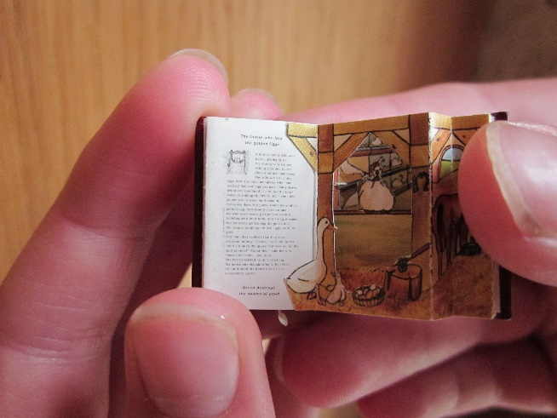
Very small version of something

Word of the Day!
ancient

It means:
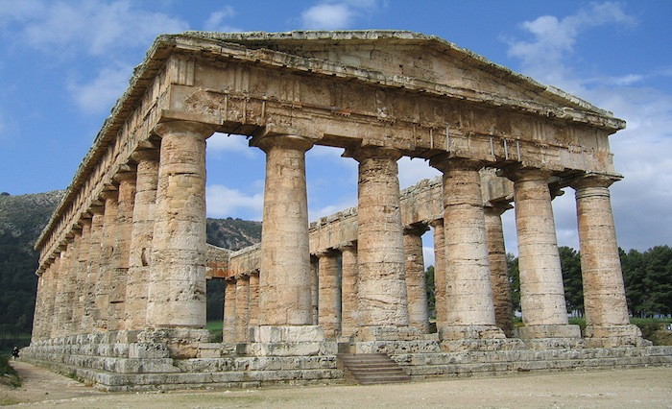
Extremely old

Word of the Day!

precious

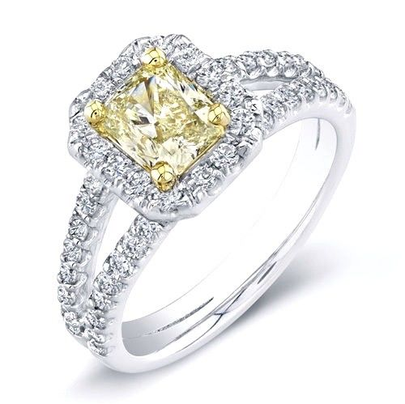
It means:
Valuable, dear

Word of the Day!

courageous

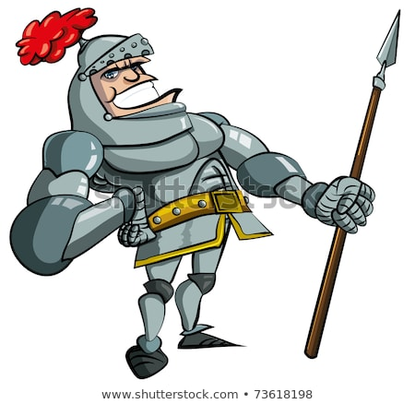
It means:
brave, fearless, bold

