Weekly attendance newsletter – Week 5 Spring term 1 2022-2023
As a school, we aim for all children to have 95% or above attendance.
From September until this week, our overall school attendance is 90.3%
Last week, our overall school attendance was 93.2% (counting children at or above mandatory school age = 5).
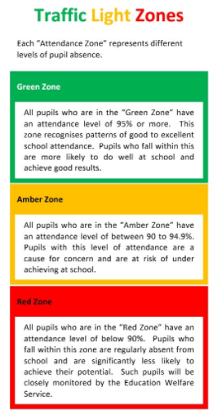
STRIVE FOR 95+%
The best place for your children to be every day is in school.
 | Last week | Two weeks ago
2-year-olds | 92.5% | 82.9%
F1 | 100% | 92.2%
F2 | 98.4% | 96.5%
Y1 | 86.5% | 91.7%
Y2 | 95.7% | 96.2%
Y3 | 92.7% | 96.3%
Y4 | 95.7% | 93.1%
Y5 | 90.1% | 92.9%
Y6 | 93.3% | 86.8%

