Literacy-
To think of and write a short, simple sentence.
(Listening to and hearing sounds in CVC and CVCC words.
Identifying sounds on a sound mat.
Listens to stories and is beginning to anticipate what may happen next.
Knowing that words can be written.
Knowing the sounds that the taught letters make.
Knowing what the taught letters looks like.
Knowing how to write the taught letters.
Recognising taught HFW in text.
Knows how to spell some familiar words.

Maths-
children count to 10 and represent numbers using concrete and pictorial representations. The ten frame and counters are used for the first time and the concept of number bonds is explored.
children identify more or less than a number up to 10, introducing the concept of addition by combining two groups of objects and of subtraction as the difference between two amounts.
the part-whole model is used to introduce the concept of addition as the combining of two parts into a whole. The vocabulary of altogether is used throughout.
Compare quantities up to 10 in different contexts, recognising when one quantity is greater than, less than or the same as the other quantity children will meet, for the first time, length, height and weight. They will learn how to compare two or more items using the vocabulary of measure and will begin to use non-standard measures to measure then compare items.

F2 Spring 1 skills and knowledge
Physical-
To handle tools, objects, construction and malleable materials safely and with increasing control.
To negotiate space effectively.
To know why it is important to handle different apparatus safely.
To know how to use scissors effectively.

PSE-
To learn right from wrong.
To understand how to make the right choices and the consequences of not making the right ones.
To be able to talk about why a character has made a poor choice and what the consequences are.
To be able to talk about how the character could have made a better choice.

UOW-
To talk about a special event in their life with confidence (History Link)
Know that their own experiences differ to those of others.(History Link)
Identify some similarities and differences between ways of life in different periods.(History Link)
I can talk about features of my own immediate environment and how environments may vary from one another(Science/ Geography Link)
I can make observations and express their views of the environment.
(Science/ Geography Link)
To understand a simple map (Geography Link)
To create won maps
To talk about their own journeys using different transport
To talk about Liverpool, The River Mersey and the Mersey tunnel.
To be able identify Liverpool on a map
Identify land and water on map (Geography)
To compare old and new types of transport.(History)
To begin to understand that things happened a really long time ago.
(History Link)

EAD-
To use resources to create own props .(DT/Art Link)
Constructs with a purpose in mind, using a variety of resources. (DT Link)
To effectively use instruments to tap a simple beat. (Music Link)
To understand that pictures can be created by making observations or by using imagination.(Art Link)
To use paints, pastels and other resources to create observational drawings .(Art Link)
For children to be able to safely construct with a purpose and evaluate their designs. (DT Link)
To be able to play instruments along to a simple beat. (Music Link)
C&L-
Express their ideas and feelings about their experiences.

To describe familiar texts with detail and using full sentences.

To being to ask questions about familiar aspects of their environment and their learning.
To know different features of texts.

To talk confidently about why things happen using new vocabulary learnt.

To engage in meaningful conversations with others.

Curriculum- What we will do……
Theme  Our World |  | 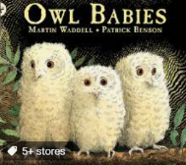  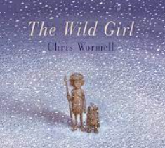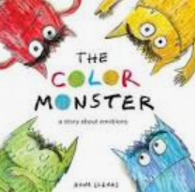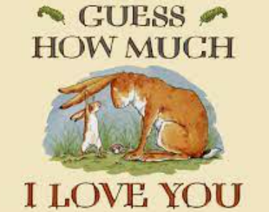 |  |  |  | Important days/dates  Chinese New Year- Festivals  Valentine’s Day- Love  Burns night- Jan 25th  Mental Health
Role Play |  | Vets, Winter café, Cave.
P.S.E | Physical development |  | Communication and Language/Literacy | Maths | Understanding the world |  | Expressive arts
Talk about the choices of the Wild Girl  What right and wrong choices has she made  Talk about the friendships she has made  Discuss personalities of the different Owls. What it means to be brave | To handle tools, objects, construction and malleable materials safely and with increasing control.  Use the creative area independently choose materials. Correctly move equipment around the room  Tidy equipment away safety  Use the cutting try to practise scissor skills. Try to progress through the different scissors. |  | Character role play  Discuss what makes them happy  What do they do when they are excited  Sequence story, start talking about the beginning middle and end.  Understand main characters of a story.  Write simple sentences | Power Maths Autumn 2 | Owl Babies- who looks after the owls and us?- Vets, doctors, fire fighters  Learn about Nocturnal animals- bat, fox, owl  Name baby animals and discuss their habitats- compare  Look how life was in the Stone age- compare  Compare environments  Discuss the changes in seasons throughout the story. |  | Create winter pictures  Cave man drawings

