Weekly attendance newsletter – Week 3 Spring term 1 2022-2023
As a school, we aim for all children to have 95% or above attendance.
From September until this week, our overall school attendance is 90%
Last week, our overall school attendance was 94.1% (counting children at or above mandatory school age = 5).
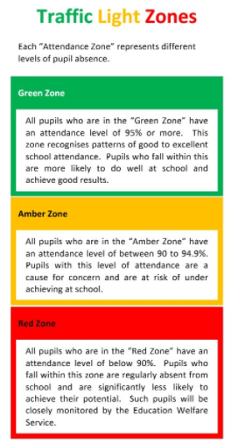
STRIVE FOR 95+%
The best place for your children to be every day is in school.
 | Last week | Two weeks ago
2-year-olds | 95.7% | 94%
F1 | 100% | 98.6%
F2 | 96.5% | 87.3%
Y1 | 95.8% | 90.4%
Y2 | 94.2% | 91.9%
Y3 | 87.2% | 82.4%
Y4 | 98.8% | 85.8%
Y5 | 92.9% | 79.6%
Y6 | 93.6% | 85%

