**Weekly attendance newsletter – Week 1 Summer 2 2022-2023**

We strive for every pupil to be present for every day that school requires a child to attend.

From September until this week, our overall school attendance is **90.9%**

Last week, our overall school attendance was **91.6%** (counting children at or above mandatory school age = 5).

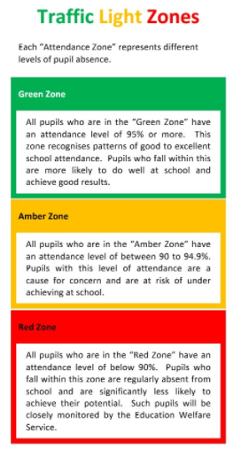STRIVE FOR 100%

**The best place for your children to be every day is in school.**

|  |  |
| --- | --- |
|  | **Last week of term** |
| 2-year-olds | 74.3% |
| F1 | 75% |
| F2 | 89.6% |
| Y1 | 96.4% |
| Y2 | 97.6% |
| Y3 | 90.8% |
| Y4 | 88.3% |
| Y5 | 90.4% |
| Y6 | 88.2% |