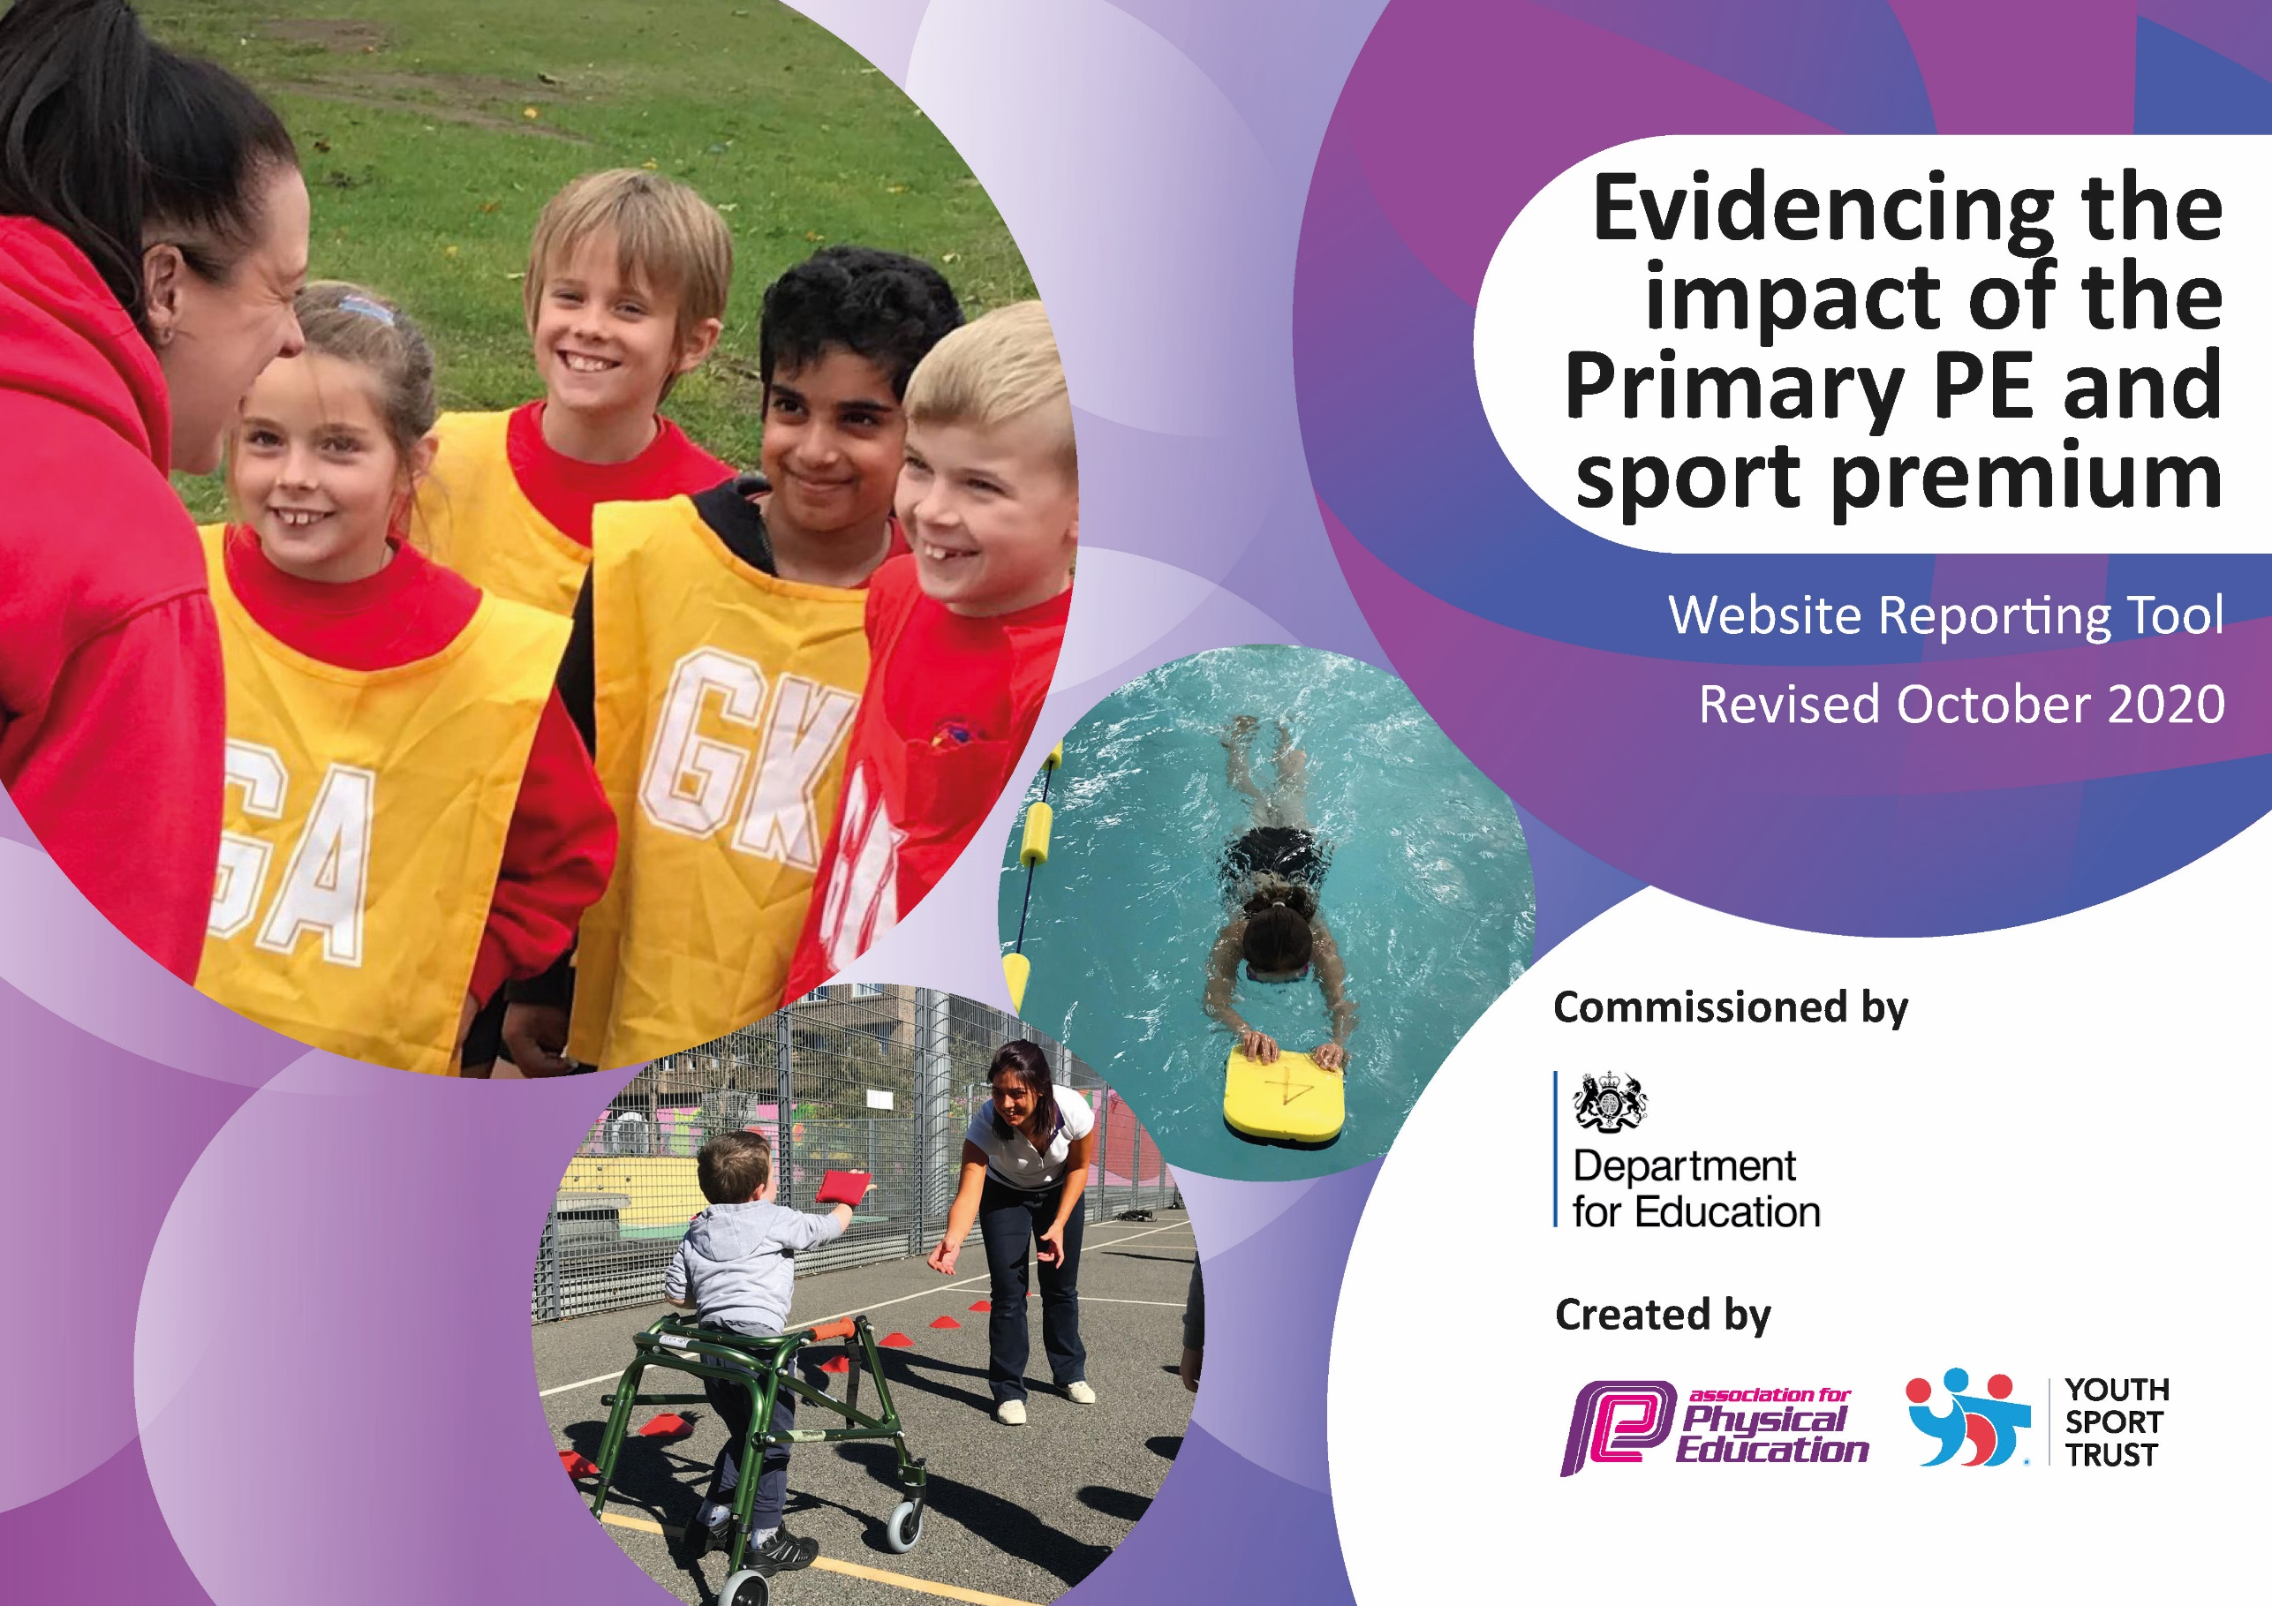
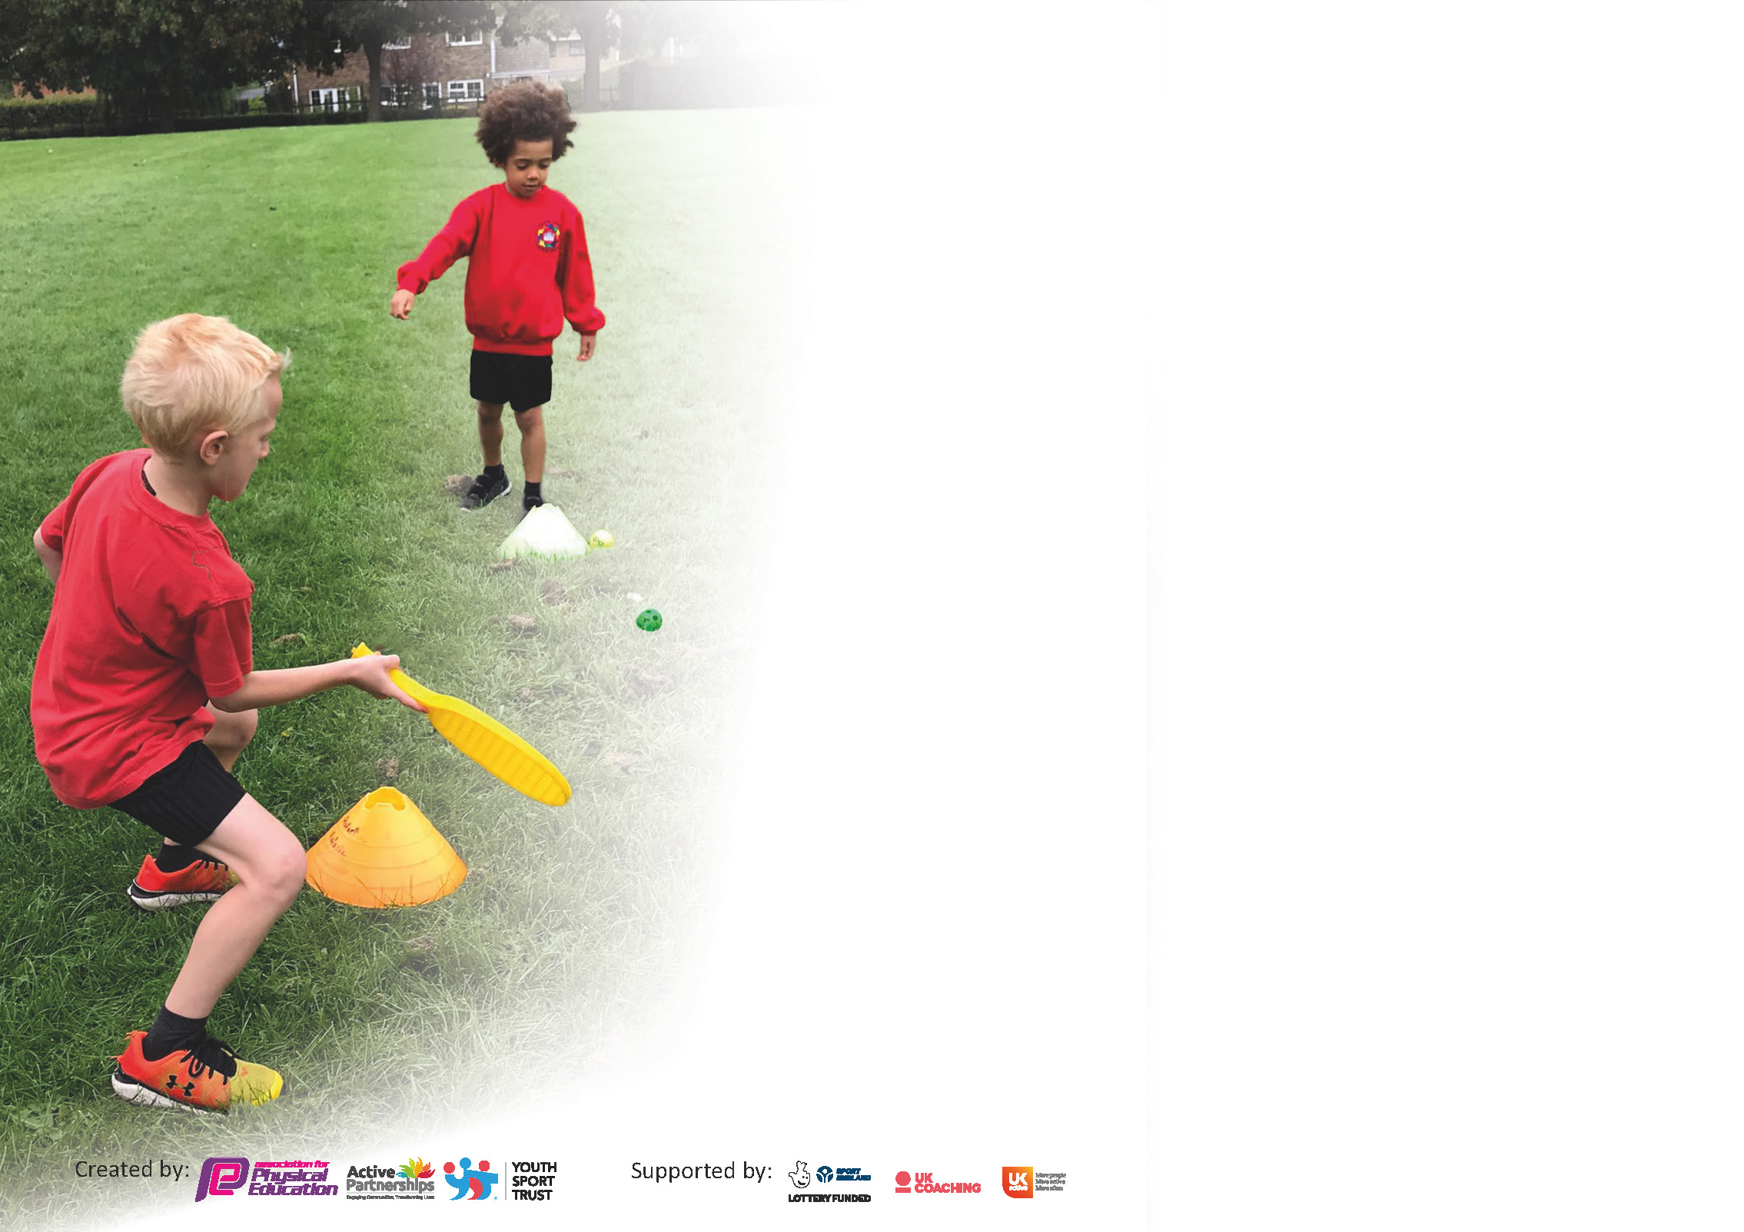

It is important that your grant is used effectively and based on school need. The Education Inspection Framework (Ofsted 2019 p64) makes clear there will be a focus on ‘whether leaders and those responsible for governors all understand their respective roles and perform these in a way that enhances the effectiveness of the school’.

Under the Quality of Education criteria (p41) inspectors consider the extent to which schools can articulate their curriculum (INTENT), construct their curriculum (IMPLEMENTATION) and demonstrate the outcomes which result (IMPACT).

To assist schools with common transferable language this template has been developed to utilise the same three headings which should make your plans easily transferable between working documents.

Schools must use the funding to make additional and sustainable improvements to the quality of Physical Education, School Sport and Physical Activity (PESSPA) they offer. This means that you should use
the Primary PE and sport premium to:

- Develop or add to the PESSPA activities that your school already offer
- Build capacity and capability within the school to ensure that improvements made now will benefit pupils joining the school in future years

Please visit gov.uk for the revised DfE guidance including the 5 key indicators across which schools should demonstrate an improvement. This document will help you to review your
provision and to report your spend. DfE encourages schools to use this template as an effective way of meeting the reporting requirements of the Primary PE and sport premium.

We recommend you start by reflecting on the impact of current provision and reviewing the previous spend.

Schools are required to publish details of how they spend this funding as well as on the impact it has on pupils’ PE and sport participation and attainment by the end of the summer term or by 31st July 2021 at the latest.

** In the case of any under-spend from 2019/20 which has been carried over this must be used and published by 31st March 2021.

We recommend regularly updating the table and publishing it on your website throughout the year. This evidences your ongoing self-evaluation of how you are using the funding to secure maximum, sustainable impact. Final copy must
be posted on your website by the end of the academic year and no later than the 31st July 2021. To see an example of how to complete the table please click HERE.
Created by: Supported by:

Please note: Although there has been considerable disruption in 2020 it is important that you publish details on your website of how you spend the funding - this is a legal requirement.
Support for review and reflection - considering the 5 key indicators from DfE, what development needs are a priority for your setting and your pupils now and why? Use the space below to reflect on previous spend and key achievements and areas for development.

N.B. In this section you should refer to any adjustments you might have made due to Covid-19 and how these will influence further improvement.
Key achievements to date until July 2020: | Areas for further improvement and baseline evidence of need:
Increased PE equipment stock to provide PE lessons for multiple classes during the school day whilst still following Covid guidelines.  Set up and implemented an online PE remote learning hub using Google classrooms, our school website and class dojo.  Redesigned break and lunch time so provide social distanced physical challenges.  Set up and ran online weekly physical challenges titled “Stay at home healthy to provide children competitive challenge during remote learning.  Entered a variety of online and virtual competitions to maintain Level 2 competition throughout lockdown. | More cross curricular links to physical activity  Activities that link competition between home learners and key worker/ vulnerable children in school.

Did you carry forward an underspend from 2019-20 academic year into the current academic year? YES/NO * Delete as applicable

If YES you must complete the following section
If NO, the following section is not applicable to you

If any funding from the academic year 2019/20 has been carried over you MUST complete the following section. Any carried over funding MUST be spent by 31 March 2021.
Academic Year: September 2020 to March 2021 | Total fund carried over: £17820 | Date Updated: 16/2/21
What Key indicator(s) are you going to focus on?  Providing mental health and well-being support through physical activity. |  |  |  | Total Carry Over Funding:
 |  |  |  | £0
Intent | Implementation |  | Impact

Meeting national curriculum requirements for swimming and water safety.  N.B Complete this section to your best ability. For example you might have practised safe self-rescue techniques on dry land. | Figures reflect the children missing 9 months of weekly swimming due to Covid.
What percentage of your current Year 6 cohort swim competently, confidently and proficiently over a distance of at least 25 metres?  N.B. Even though your pupils may swim in another year please report on their attainment on leaving primary school at the end of the summer term 2021. | 30%
What percentage of your current Year 6 cohort use a range of strokes effectively [for example, front crawl, backstroke and breaststroke]? | 30%
What percentage of your current Year 6 cohort perform safe self-rescue in different water-based situations? | 40%
Schools can choose to use the Primary PE and sport premium to provide additional provision for swimming but this must be for activity over and above the national curriculum requirements. Have you used it in this way? | Yes/No

Action Plan and Budget Tracking
Capture your intended annual spend against the 5 key indicators. Clarify the success criteria and evidence of impact that you intend to measure to evaluate for pupils today and for the future.

Academic Year: 2020/21 | Total fund allocated: £ | Date Updated:
Key indicator 1: The engagement of all pupils in regular physical activity – Chief Medical Officers guidelines recommend that primary school pupils undertake at least 30 minutes of physical activity a day in school |  |  |  | Percentage of total allocation:
 |  |  |  | %
Intent | Implementation |  | Impact
Active Lunchtimes | Employ a TA to provide this every lunchtime is KS2 | £2838 (lunch) + £492 (Break times) | 45 pupils have 30 minutes additional physical activity through a variety of games and activites. (120 pupils after covid resrictions(
Swimming | Year 5 and 6 to swim in catch up blocks | £2600 | To be delivered Easter 2021
Key indicator 2: The profile of PESSPA being raised across the school as a tool for whole school improvement |  |  |  | Percentage of total allocation:
 |  |  |  | %
Intent | Implementation |  | Impact
PowerUP! | Member of staff to design and deliver mental health programme PowerUP! | £1107 | To be delivered Easter 2021
Additional PE equipment | Sport’s equipment audited with essential PE equipment orders bulked up for additional use (Key equipment includes balls, targets and ropes) | £555 | All school based children able to continue PE lessons involving skill base with specialist equipment without violating covid rules.
Sport and Well being Website design | Member of staff to revamp school website inline with covid restrictionsq | £123 | All children remote learning now have access to approx. 20 hours+ of home learning activities to use.
Personal Best Programme | Employ a member of staff to design and implement a personal best programme for children in school identified as needing assistance with self-worth. | £1625 | Programme completed with 16 children across KS2. All children who took part showed improvements in self-worth based on before and after questionnaires.
Christmas Sport’s Day | Member of staff to provide a full day of sport activites | £250 | All children in school had an additional hour of sport’s activities to replace traditional summer sports day missed by Covid

Key indicator 3: Increased confidence, knowledge and skills of all staff in teaching PE and sport |  |  |  | Percentage of total allocation:
 |  |  |  | %
Intent | Implementation |  | Impact
Edsential PE scheme of work | Purchase a scheme of work in line with current national curriculum guidelines | £200 (annual subscription) | Some of these new lessons have not been able to be used due to covid restrictions but advice has been sought from the provider to offer a variety of fitness and skills based lessons instead to provide for the children in school.
Maths of the Day/ Teach Active | Provide opportunities for active English and Maths sessions across the year groups | £545 (annual subscription) | All staff trained in school on how to use Active Maths and English using the Teach active training. Every child at school receives 15-20 minutes additional physical activity a day through Active Learning. All remote learners receive weekly links to physical activity through Teach Active homework activity links.
PE CPD for Y3/5/6 | Member of staff to train other teachers in using the PE scheme of work adapted to Covid | £875 | 12 hours of training provided for 4 teachers from Y3/5/6 leading to 35 children receiving high quality PE lessons during covid restrictions.
Key indicator 4: Broader experience of a range of sports and activities offered to all pupils |  |  |  | Percentage of total allocation:
 |  |  |  | %
Intent | Implementation |  | Impact
Football  Multi sports  Trampolining (May 2021  (Fencing, trampolining, karate and fitness clubs all cancelled due to covid)  Residential trip to Low bank Ground for Y4 and 6 cancelled due to covid | Employ football coach | £1100  £656  £1160 | 85 children from 4-11 years old accessed additional football sessions free of charge from Sep 2019- Mar 2020 (would have continued to Jul 2020 but stopped due to covid)  40 children took part in additional sport activity (Y2-Y6)  To be delivered May 2021

Key indicator 5: Increased participation in competitive sport |  |  |  | Percentage of total allocation:
 |  |  |  | %
Intent | Implementation |  | Impact
Currently no budget required for competitive sport as all sport accessed through Wirral School games online offers has been free.

Signed off by
Head Teacher:
Date:
Subject Leader:
Date:
Governor:
Date:

