Word of the Day!

For each word can you:
- put it into a sentence
- find a synonym (word that has the same meaning)
- create your own picture to go with each word

Word of the Day!

exquisite

It means:
beautiful, stunning, gorgeous

Word of the Day!

immediately

It means:
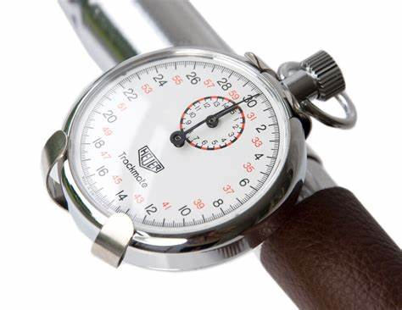
straight away, without delay,
at once, that instant

Word of the Day!
swiftly

It means:
quickly, rapidly

Word of the Day!

bellowed

It means:
shouted in a loud, deep voice

Word of the Day!

enquired

It means:
asked, questioned

