Weekly attendance newsletter – Week 5 Autumn term 2 2022-2023
As a school, we aim for all children to have 95% or above attendance.
From September until this week, our overall school attendance is 90.7%
Last week, our overall school attendance was 86.7% (counting children at or above mandatory school age = 5).
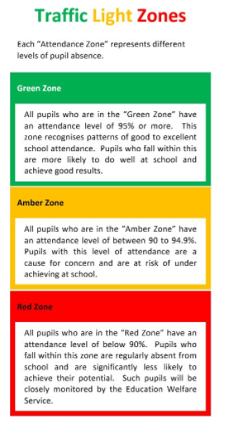
STRIVE FOR 95+%
The best place for your children to be every day is in school.
 | Last week | Two weeks ago
2-year-olds | 81% | 84.2%
F1 | 93.4% | 82.8%
F2 | 82.2% | 93.4%
Y1 | 91.7% | 95.8%
Y2 | 92.3% | 96.2%
Y3 | 84.6% | 88.8%
Y4 | 85% | 98.1%
Y5 | 93.3% | 89.2%
Y6 | 78.2% | 83.9%

