**Weekly attendance newsletter – Week 5 Spring Term 2 2022-2023**

We strive for every pupil to be present for every day that school requires a child to attend.

From September until this week, our overall school attendance is **90.6%**

Last week, our overall school attendance was  **90.9%** (counting children at or above mandatory school age = 5).

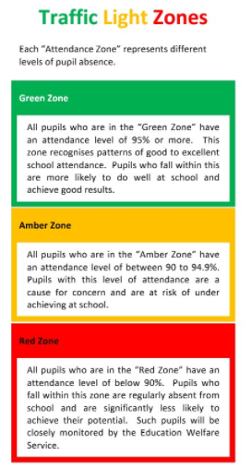STRIVE FOR 100%

**The best place for your children to be every day is in school.**

|  |  |  |
| --- | --- | --- |
|  | **Last week** | **Two weeks ago** |
| 2-year-olds | 87.1% | 61.4% |
| F1 | 80% | 70.2% |
| F2 | 88.6% | 92% |
| Y1 | 95.7% | 90.6% |
| Y2 | 86% | 90.7% |
| Y3 | 93.3% | 93.1% |
| Y4 | 97.6% | 98% |
| Y5 | 86.7% | 85.6% |
| Y6 | 88.6% | 75.4% |