Name: Date:

Grammar, punctuation and spelling revision booklet

Sentences

Sentences can be:
Statements e.g. The man was angry.

Questions e.g. Where is the man?

Commands e.g. Draw a man.
These are usually written in the imperative and start with a verb.

Exclamations e.g. What a good idea!

Often start with ‘what’ or ‘how’, but may be a single word.

Subject

Subject
verb
subject

The subject is often who or what does something. The subject is usually the noun, noun phrase or pronoun before the verb.

The man walked away.
Subject
Verb

Phrases and Clauses

A phrase is a group of words that can be understood as a unit. There are:

Noun phrases e.g. ‘my old chair’
Adjectival phrases e.g. ‘very bright’
Adverbial phrases e.g. ‘extremely quickly’
Prepositional phrases e.g. ‘across the playground’

A clause is a phrase which contains a subject and a verb.

E.g. He slept all night long.

A main clause is a clause which can be understood on its own.

E.g. The girl was upset.

A subordinate clause gives more meaning to the main clause. It cannot be used on its own and often starts with a conjunction.

E.g. Because she had lost her bag, the girl was upset.

Conjunctions

Conjunctions link clauses and can also link words and phrases.

Coordinating conjunctions

These are:

for, and, nor, but, or , yet, so.

Co-ordinating conjunctions link clauses that are of the same importance in a sentence.

He went to the door and opened it.

The monster was small yet scary.

Subordinating conjunctions

These include:

after, although, as, because, before, for, if, since, so, unless, when, whereas, whether, whilst, though, till, until.

A subordinating conjunction starts a subordinate clause. The subordinate clause is not as important as the main clause.

They can be use in the middle or at the beginning of a sentence.

Although he was tired, he worked all day.

He worked all day, although he was tired.

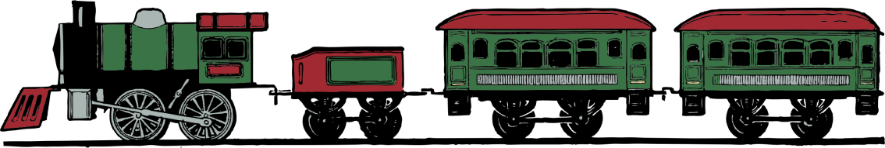
Conjunction junction:
What’s your function?

Relative Clauses

A relative clause is a special type of subordinate clause and begins with a relative pronoun.

The relative pronouns are:
that, which, whose, whom, who

The horse, that is standing in the corner of the field, is mine.
relative clause

These gloves, which were a gift, are very comfortable.
relative clause

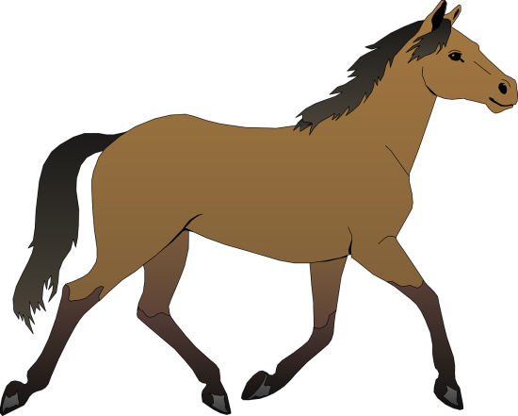

Tenses

Present tense
Verbs in the present tense talk about the present and the future.
John plays football
The train leaves at four.
The fireworks are starting tonight.

Simple present tense
John plays. They play. He doesn’t play.

Present progressive tense
The form used to describe an event that is happening now.
John is playing. They are playing.

Present perfect tense
The verb form used to describe an event that has happened and or is still happening now.
John has played football and his kit is dirty.
They have played football together for 2 years

Present perfect progressive tense
The verb form used to describe an event that started happening in the past and is still happening now.
John has been playing football all afternoon.

Past tense
Verbs in the past tense talk about the past, talk about imagined situations and make requests more polite e.g.
John played football.
I wish the train left earlier.
We were hoping that the fireworks would start.

Simple past tense
The verb form used to describe an event that happened earlier or in the past and is now finished.
John played. They played. They did not play.

Past progressive tense
The verb form used to describe an event that was not finished when something else happened or something that continued for a period of time.
John was playing football when it started to rain. All morning, the children were playing football.

Past perfect tense
The verb form used to describe an event that happened before something else in the past or something that started in the past and was still happening later on.
John had played football in the morning and went swimming in the afternoon. They had played football together during the summer.

Past perfect progressive tense
The verb form used to describe an event that started happening in the past and was still happening later on.
John had been playing football all afternoon.

Future Tense
Verbs in the future tense talk about what will or may happen in a future time.
John will play football this evening.
The train may leave on time.
He wants to go swimming.
They are about to ring the bell.

Infinitive

The infinitive form of a verb is its basic form e.g. walk, be, need

The infinitive often has ‘to’ in front of it.
The girl waited for the class to be quiet.

The infinitive is also used after modal verbs.
Flowers may need more water in hot weather.

Subjunctive

The subjunctive is a specific verb form. It used to express something that is wished for, suggested or commanded. The subjunctive is used after the following verbs:

to advise (that) | to ask (that)
to command (that) | to demand (that)
to desire (that) | to insist (that)
to propose (that) | to recommend (that)
to request (that) | to suggest (that)
to urge (that) | to pray (that)

These sentences contain subjunctives:

The school requests that blazers be worn at all times.
If the children were older, they could walk home alone.
She insisted that John come to the party.

Active and Passive Voice

Often verbs can be either active or passive.

Active Voice:
The subject is often who or what does something. This sentence has an active verb:
The boy broke the window.

Passive Voice:
The subject is the person or thing that would be the object in an active sentence. The focus is on what happened, instead of who does something. These sentences have a passive verb:
The window was broken by the boy.
The doors are opened at 8:45 am.

Nouns

Common Nouns

These are the names of objects and things which are not specific, proper nouns, e.g. boy, day

Proper Nouns

These are names of a specific person, place, time or organisation and always have a capital letter .e.g. Sunday, New York, Asda

Abstract Nouns

These are things which cannot be physically touched or seen. They are the names of ideas or feelings e.g. anger, idea, suffering

Collective Nouns

These refer to a group of people or animals.
e.g. audience, crowd, herd, flock

Countable Nouns

These can be counted and made into a plural
(usually by adding –s) e.g. book, chair

Non-countable Nouns

These cannot be counted and cannot be made plural
e.g. bread, money, information

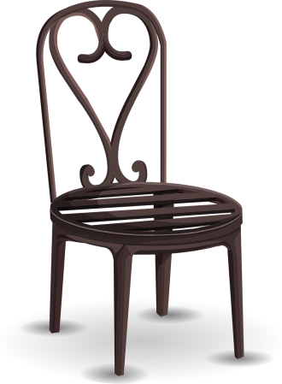
Pronouns

Pronouns are words which can be used instead of nouns and noun phrases. Examples include: me, herself, yours, this, who, everything.

Personal pronouns

These refer to people or things that have already been referred to.
John was afraid of the dark until he got older

Most have different forms according to whether they are singular or plural, the subject or the object of a sentence.

 | Singular | Plural
1st person subject  1st person object | I  me | we  us
2nd person subject  2nd person object | you  you | you  you
3rd person subject  3rd person object | he, she, it  him, her, it | they  them

Possessive pronouns

These tell you who owns the thing or who is involved in the action.
James told the teacher that the shoes were his.

 | Singular | Plural
1st person | mine | ours
2nd person | yours | yours
3rd person | his, hers, its | theirs

Demonstrative pronouns

These are used to identify whether things are near or further away.

this that these those

Speech

Direct speech is when you write the exact words that someone says. It is punctuated using inverted commas (speech marks).
“Can we go outside?” asked the children.

Reported (or indirect) speech is when the words that someone has spoken are reported. Inverted commas (speech marks) are not used.
The children asked if they could go outside.

Punctuation

Question mark (?) A question mark is used at the end of a sentence to show that it is a question.
Are you being served?

Exclamation mark (!) An exclamation mark is used at the end of a sentence to show that it is an exclamation or a command.
What a good idea!
Come here!

Comma (,) A comma is used to separate items in a list or to separate clauses or phrases in a sentence.
We need eggs, milk, flour and sugar. When we go home, we will make dinner.

Colon (:) A colon can be used to introduce a list or to introduce examples or explanations.
James plays the following instruments: piano, guitar and trumpet.
Cats have sharp claws: they use them to catch their prey.

Semicolon (;) A semicolon can be used between two sentences or main clauses of equal importance or to separate longer phrases in a list.
The concert was amazing; I had a fabulous time.
I bought: a tub of luxury chocolate ice cream; a twin pack of tissues; and some freshly picked tomatoes.

Dash (–) A dash is used in informal writing where commas and semicolons might normally be used.
James loved playing football – especially on Sundays.

Parenthesis ( ) Parenthesis is a word or phrase inside brackets, commas or dashes which is added to a sentence as an explanation or afterthought. If you take out the words in parenthesis, the sentence should still make sense.
The man boarded the train (dragging his heavy bag behind him) and looked for a seat.
The man boarded the train, dragging his heavy bag behind him, and looked for a seat.
The man boarded the train – dragging his heavy bag behind him – and looked for a seat.

A Glossary of English words

adjective | Can be used before a noun, to modify it e.g. the gloomy wood  Can be used after the verb ‘be’ e.g. the wood was gloomy
adverb | Can be used to modify a verb, an adjective or another adverb. Adverbs often describe manner or time. The weather was very hot. The children soon became tired. They slowly closed their eyes.
antonym | Words are antonyms if their meanings are opposite e.g. hot–cold,  in–out
apostrophe | Apostrophes can be used to show omission (missing letters) e.g. They’re going out. They can also mark possession e.g. The teacher’s bag was on the desk.
article | The articles are the most common types of determiner a or an (indefinite) and the (definite).
auxiliary verbs | The verbs be, do and have can be used as auxiliary verbs. They help the main verb make sense. She was swimming. Does he like chocolate? They have finished. Modal verbs are also a type of auxiliary verb.
determiner | Determiners are used before a noun or at the start of a noun phrase. It tells you which one, how many or how much. Examples include: a, the, some, any, my, each, either, no. E.g. No boys were found outside.
ellipsis | This is a set of three dots used to show that a word has been omitted or the sentence is not finished e.g. Finally, there he was...
finite verb | A finite verb shows the tense e.g. present or past. Sentences typically have at least one finite verb e.g. She wanted a horse.

fronting, fronted | A word or phrase that usually comes after the verb can appear at the beginning of a sentence. This is called fronting. Fronted adverbials appear before the verb e.g. After the match, we had a party.
homonym | Words with different meanings which look exactly the same when written and sound exactly the same when pronounced e.g. The child had the right answer. The house is on the right. We went to the fair. It was a fair test.
homophone | Word with different meanings that sound exactly the same when pronounced e.g. He was a brown bear. The cupboard was bare.
hyphen | A hyphen is shorter than a dash and is used to join two or more words, or to join a prefix to a word e.g. co-ordinate, a two-year-old boy
modal verb | Modal verbs are a type of auxiliary verb that change the meanings of other verbs. The main modal verbs are: can, will, would, may, might, shall, should, must, ought to.
noun | Nouns identify people, places and things. They can be used after determiners e.g. the table, some information.
object | In some sentences the verb has an object. This is usually a noun, noun phrase or pronoun which comes straight after the verb. E.g. I like the old painting. The dog chased after him.
plural | If you are just talking about one of something, it is singular. If there is more than one, it is plural. A plural noun is often made by adding a suffix –s or -es e.g. flower–flowers, loaf–loaves. Some plurals have a different form e.g. person– people, child–children.
possessive | This can be a noun with an apostrophe e.g. The girl’s pen, James’ bag or a possessive pronoun e.g. The homework book on the table is mine.

prefix | A prefix is added at the beginning of a word to turn it into another word e.g. disagree, impossible.
preposition | Prepositions are used before a noun, noun phrase or pronoun and link it to another word in the sentence. They often tell us about positon, direction, timing or a relationship e.g. above, during, against, without.
Standard English | This is the English taught in school. It is used in most books, newspapers and formal documents. Most writing needs to be in Standard English and it is used for formal speaking.
subject | The subject of a verb is often the do-er or be-er (who or what does something). It is usually the noun, pronoun or noun phrase before the verb e.g. The plan worked. Children play outside.
suffix | A suffix is an ending, used at the end of a word to turn it into another e.g. waited, runner, miserable, enjoyment.

