**Weekly attendance newsletter – Week 2 Summer 2 2022-2023**

We strive for every pupil to be present for every day that school requires a child to attend.

From September until this week, our overall school attendance is **90.7%**

Last week, our overall school attendance was **83.7%** (counting children at or above mandatory school age = 5).

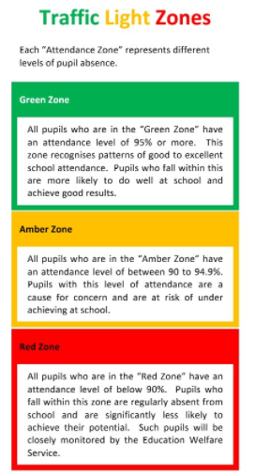STRIVE FOR 100%

**The best place for your children to be every day is in school.**

|  |  |  |
| --- | --- | --- |
|  | **Last week** | **Two weeks ago** |
| 2-year-olds | 80% | 74.3% |
| F1 | 81% | 75% |
| F2 | 95.6% | 89.6% |
| Y1 | 87.7% | 96.4% |
| Y2 | 68% | 97.6% |
| Y3 | 90.8% | 90.8% |
| Y4 | 90.4% | 88.3% |
| Y5 | 74.3% | 90.4% |
| Y6 | 79.3% | 88.2% |