1. 3 + 5 =
Key Stage 1 Arithmetic Assessment
Addition and subtraction within 10
2. 9 – 0 =
3. 8 – 1 =
4. 3 + 3 =
5. 2 + 7 =
6. 7 – 3 =
7. 1 + 1 =
8. 2 + 4 =
9. 8 + 2 =
10. 8 – 4 =
11. 10 – 7 =
12. 1 + 9 =
13. 0 + 6 =
14. 5 – 2 =
15. 4 + 4 =
16. 9 - 6 =
17. 5 + 4 =
18. 3 + 7 =
19. 6 – 1 =
20. 7 – 6 =

1. 12 + 5 =
Key Stage 1 Arithmetic Assessment
Addition and subtraction not crossing 10s
2. 16 – 4 =
3. 11 + 3 =
4. 29 + 1 =
5. 19 – 5 =
6. 15 – 0 =
7. 23 + 3 =
8. 18 – 3 =
9. 14 – 4 =
10. 17 + 3 =
11. 40 – 1 =
12. 18 + 0 =
13. 12 + 8 =
14. 13 + 4 =
15. 13 – 2 =
16. 19 – 3 =
17. 41 + 2 =
18. 27 – 1 =
19. 15 + 5 =
20. 17 – 4 =
1. 10 x 2 =
Key Stage 1 Arithmetic Assessment
Counting in 2s, 5s and 10s and Finding ½ and ¼ of a number
2. 5 x 3 =
3. 2 x 6 =
4. 2 x 2 =
5. 5 x 5 =
6. 10 x 8 =
7. 2 x 7 =
8. 5 x 8 =
9. 10 x 5 =
10. 2 x 5 =
11. ½ of 12 =
12. ½ of 8 =
13. ¼ of 8 =
14. ¼ of 20 =
15. ½ of 10 =
16. ¼ of 12 =
17. ½ of 18 =
18. ¼ of 16 =
19. ½ of 6 =
20. ½ of 20 =
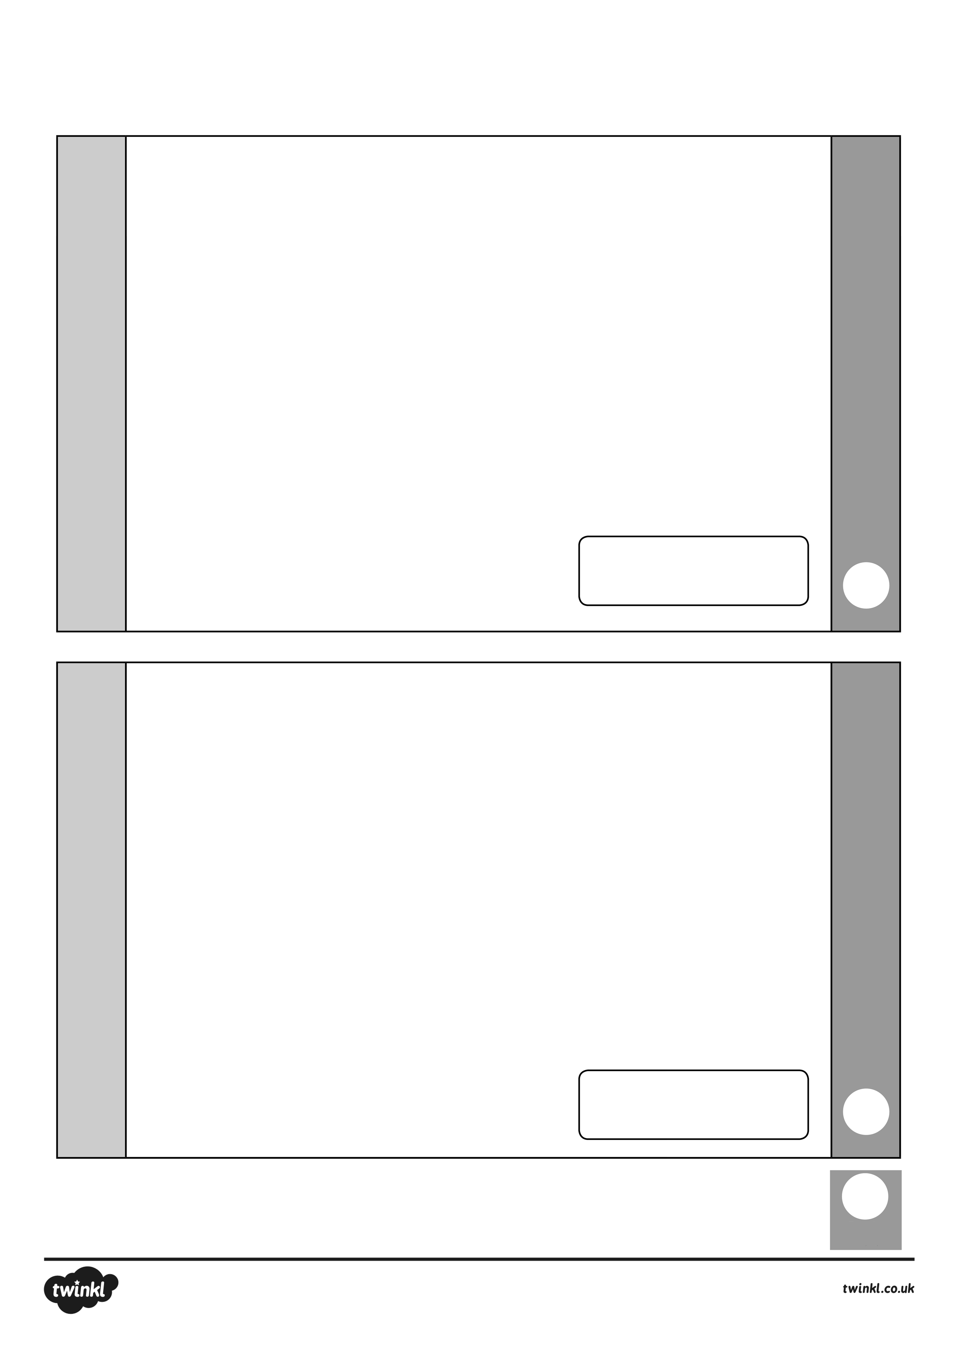
total
mark
mark
7 + 7 =
9 + 4 =
2
1
Key Stage 1 Arithmetic Assessment
Addition and Subtraction crossing 10s
mark
mark
total
9 + 7 =
8 + 6 =
4
3
Key Stage 1 Arithmetic Assessment
Title
total
mark
mark
5
6
5 + 7 =
3 + 8 =
Key Stage 1 Arithmetic Assessment
Title
Answers
Key Stage 1 Arithmetic Assessment
Title

Page 1
1. 8
2. 9
3. 7
4. 6
5. 9
6. 4
7. 2
8. 6
9. 10
10. 4

Page 2
1. 17
2. 12
3. 14
4. 30
5. 14
6. 15
7. 26
8. 15
9. 10
10.20

11. 3
12. 10
13. 6
14. 3
15. 8
16. 3
17. 9
18. 10
19. 5
20. 1

11. 39
12. 18
13. 20
14. 17
15. 11
16. 16
17. 43
18. 26
19. 20
20. 13
Answers
Key Stage 1 Arithmetic Assessment
Title

Page 3
1. 20
2. 15
3. 12
4. 4
5. 25
6. 80
7. 14
8. 40
9. 50
10. 10

Page 4 – 6
1. 14
2. 13
3. 14
4. 16
5. 12
6. 11

11. 6
12. 4
13. 2
14. 5
15. 5
16. 3
17. 9
18. 4
19. 3
20. 10

