EAD-
To use what they have learnt about media and materials in an original way and be able to explain their choices.(Art Link)
Selects appropriate resources and adapts work where necessary. (DT/Art Link)
To move along to the beat of a familiar song. (Music Link)
To know the different uses and purposes of a range of media and materials. (DT/Art Link)
For children to be able to safely construct with a purpose and evaluate their designs. (DT Link)
Express feelings in music by responding to different moods in a musical score.
Choose different instruments including the voice to create sound effects in play.
Experiment performing songs and music together with body movements to a steady beat.

Maths-
children will explore addition and subtraction through counting on and counting back. Children will use a number track to practise counting the number of jumps required to move on or back rather than the actual numbers they are landing on. This is the basis of addition and subtraction, so is vitally important.
children will explore numbers from 10 to 20 for the first time. Once confident, children will apply this new knowledge to previously taught concepts, such as comparing, representing and finding one more and one less and understanding that more will mean counting on, with the answer going up, and less will mean counting back, with the answer going down.
Children will already be familiar with numbers to 20 and will have explored five frames and ten frames, and comparative relationships between numbers using concrete manipulatives and pictorial images. In this unit, they begin to look at the patterns of doubles, halves and odd and even numbers.

F2 Summer 1 skills and knowledge
Physical-
To use a pencil effectively to form recognisable letters, most of which are formed correctly.
To show good control and co-ordination in large and small movements.
(Computing Link)
To know how to form letters correctly.
To know how to use scissors effectively.

PSE-
To learn about the different family structures.

To be able to talk about the relationships they have at home with their family and friends.

UOW-
Talking about the life cycle of plants and animals and what they need to survive. (Science Link)
Exploring a range of habitats, looking at why the animal lives like that.
(Science Link)
I can ask questions about their familiar world (where they live or the natural world).(Geography Link)
To begin to understand that things change over time.
(Science/ Geography Link)
To know the importance of recycling and its effect on the environment.
To know the effects of everyday plastic on the ocean.
To know the difference between a river and an ocean.

Literacy-
To think of and write a short, simple sentence. (Su1)
Listening to and hearing sounds in CVC and CVCC words.
Identifying sounds, including phonemes and other digraphs on a sound mat.
Checking written work and making any changes where necessary.
Listens to stories and is beginning to anticipate what may happen next.
Knowing the sounds that the taught phonemes make.
Knowing what the taught phonemes look like.
(Knowing how to write the taught letters.
(Recognising taught HFW in text.
To know that a sentence starts with a capital letter and ends with a full stop.
Knowing that sentences can be extended by using a connective
Uses learnt words and phrases to discuss familiar stories or during role play.
Knows how to spell some familiar words.

C&L-
To describe a range of different habitats around the world.
To talk about the world that we live in and how there are similarities and differences when looking at different aspects.

Curriculum- What we will do……
Theme  Great Outdoors |  | 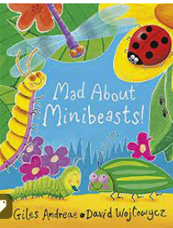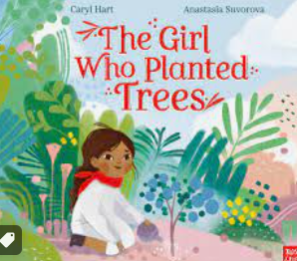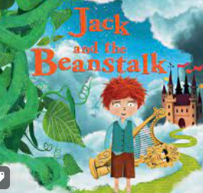 |  |  |  | Important days/weeks
Role Play |  | Vegetable shop, minibeast corner, Giants castle |  |  |  | Trips and experiences: caterpillars
P.S.E | Physical development |  | Communication and Language/Literacy | Maths | Understanding the world |  | Expressive arts
Looking at the world we live in and the impact of our actions.  Discuss how we can keep our world happy.  Understand the word responsibility. | Using a comfortable pencil grip to form letters correctly.  Moving around, under, over and through the outdoor equipment safely  Using all equipment inside appropriately making sure all is stored correctly. |  | Discussing poetry and finding the meaning  Learning new vocabulary  Creating own poem about minibeasts  List/ diagrams/ labels | Power Maths Summer 1 | Life cycle of a caterpillar  Understand what a seed needs to grow  How to look after our environment/ recycling  Learn about worms, ants and ladybirds  Look at how our environment is changing  The importance of recycling.  Labelling, plants, animals and habitats  Caring for our vegetable patch.

