Weekly attendance newsletter – Week 2 Spring term 1 2022-2023
As a school, we aim for all children to have 95% or above attendance.
From September until this week, our overall school attendance is 86%
Last week, our overall school attendance was 89.8% (counting children at or above mandatory school age = 5).
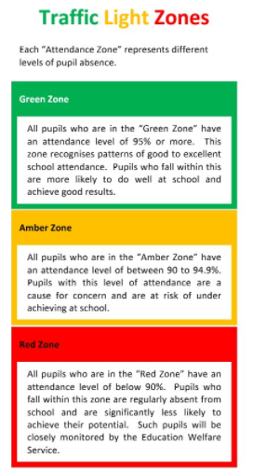
STRIVE FOR 95+%
The best place for your children to be every day is in school.
 | Last week | Two weeks ago
2-year-olds | 94% | 100%
F1 | 98.6% | 90.6%
F2 | 87.3% | 94.1%
Y1 | 90.4% | 86%
Y2 | 91.9% | 90.4%
Y3 | 82.4% | 86%
Y4 | 85.8% | 91.7%
Y5 | 79.6% | 92.4%
Y6 | 85% | 94%

