Grammar Answers
s/es
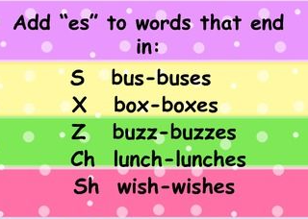
- foxes, birds, books
- chairs, bags, churches
- socks, beds, ducks
- witches, rabbits, buses
- boxes, brushes, glasses
- dogs, cats, cars

‘ed’, ‘ing’, ‘er’, ‘est’ suffixes

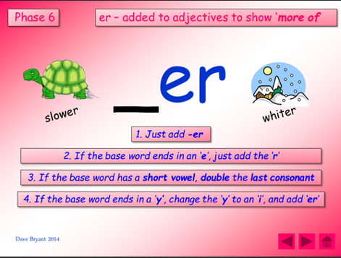
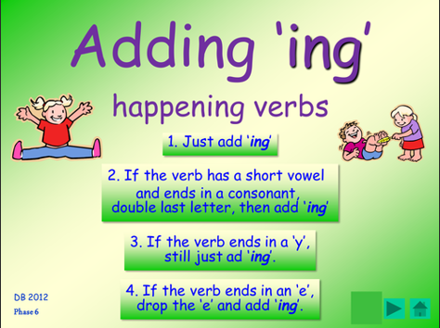
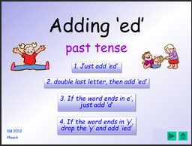

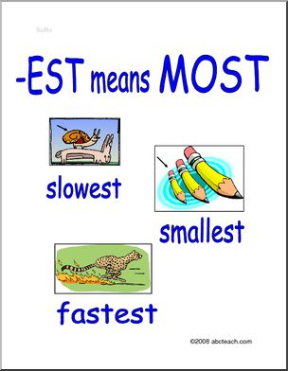

- helper
- jumped
- walker
- talking
- fastest
- slowest

Capital letters and full stops

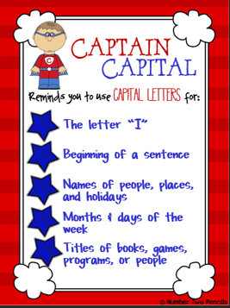

1) C
2) B
3) A
4) C
5) C
6) A

-un prefix

1) unfair
2) untie
3) undo
4) unhappy
5) unlucky
6) unlock

Capital letters and full stops

- b
- c
- a or b
- a
- c
- c

