Very early in the morning, on the first day of the week, some women were tiptoeing through the early sunshine. Three days ago Jesus had died, so they felt very sad. They were going to see the garden where he had been buried.
What a surprise they had when they arrived! There were angels in the garden and the angels had the most amazing news.
“Jesus is risen from the dead!” said the angels, and the women were so surprised that they ran back and fetched some of Jesus’ special friends.
His friends ran to see where Jesus had been buried, but he was not there. There was just an empty tomb! They went slowly back home, thinking hard.
Mary of Magdala stayed in the garden. She could not believe it. She looked in the tomb again and started to cry.
Suddenly, she realised there was someone behind her. She turned round and saw a man standing there – she thought it was a gardener.
“Why are you crying?” the man asked her. Mary started to tell him that sbe didn’t know where Jesus was. She felt very confused But then the man spoke her name.
“Mary!” he said gently. At once Mary recognised Jesus – he really was alive! She felt so happy.
Jesus wasn’t dead any more. The women saw him, and his friends saw him too, in the garden and in lots of other places.
What wonderful news. The women and the friends of Jesus told everyone about it, and that is how we know. Jesus is alive again. Alleluia!
Questions to ask about the story:

- Why were the women going to the garden?
[To see where Jesus had been buried; to be near Jesus even though they thought he was dead.]

- What do you think the women were thinking about as they crept through the early morning sunshine?

- Does anyone know what day of the week it was when the women went to the garden?
[First day of the week, Sunday, Easter Sunday.]

- Who told the women that Jesus was alive? [the angels]

- What did the women do when they heard the news?

- What do you think the friends of Jesus thought when the women came to fetch them and told them Jesus is alive again?
[Hope, fear, disbelief, ridicule, but they came anyway]

- What do you think ‘Alleluia’ might mean? [‘praise God’]

Task

- Make an ‘Easter Garden’.

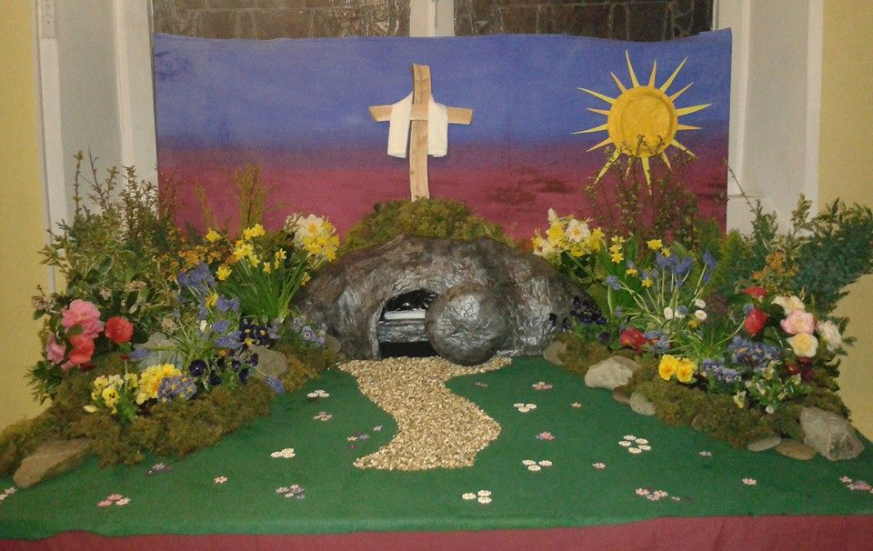
Suggestions: include some small plants; a little box for the empty tomb and a piece of white cloth in it.
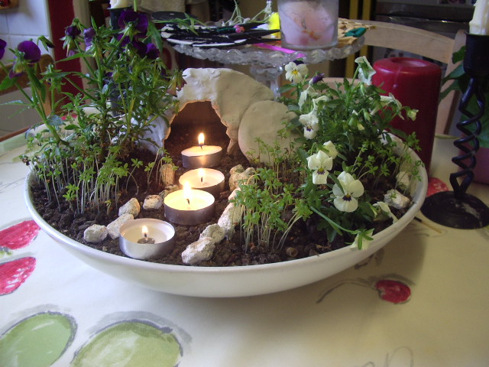

- Imagine you are in the garden.
- What would you be thinking?
- What would you see?
- Who might you meet?
- What would you say to them?

