Year 1 | Year 2 | Year 3 | Year 4 | Year 5 | Year 6
Count in 2s, 5s and 10s | Learn 2s, 5s and 10s.  Multiplication and division facts. | Learn 3s, 4s and 8s.  Multiplication and division facts. | Learn 6s, 7s, 9s, 11s, 12s.  Multiplication and division facts. | Develop speed and accuracy across all times tables.  Introduce square numbers.  Use multiplication and division facts to develop scaling. | Develop speed and accuracy.  Introduce decimal scaling using division and multiplication facts.
Daily and varied teaching activities.

Skip Counting:
- Chanting and songs e.g. Percy Parker, Mathletics, Education City, YouTube.
- Show and use visuals whilst chanting for each multiplication.

Develop learning and relationships between multiples as well as distributive law:
- Number Dial (ITP) and counting stick – use out of order.
7 x 6 =
5 x 6 + 2 x 6

Variation:
Show all multiplication facts in a variety of ways such as arrays, pictures, diagrams, dienes and calculation. Make connections throughout teaching with fractions, measurement and geometry. ‘The answer is only the beginning’ – Understand why an answer is correct or incorrect.
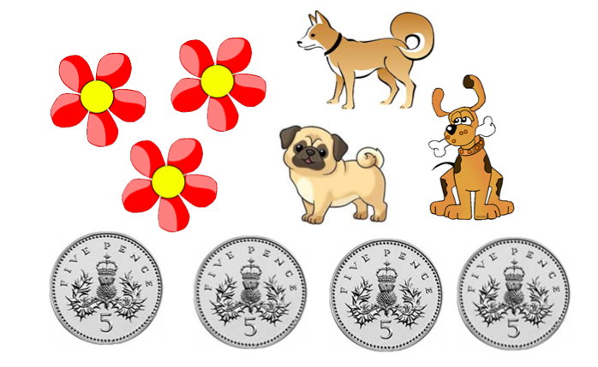
Use the diagram above to find multiples e.g. Dogs’ legs = 4 x 3 = 12 Money = 5 x 4 = 20
Time for investigating patterns and to find relationships between multiples of all times tables. Use of investigative questioning and requirement of ‘proof’ in the answers
e.g. Do all multiples of 5 end in 5?
If I double and double again, is it the same as x4?
Pick two of the above numbers and find the product. I think that there will be more odd answers than even answers, am I right or wrong?

-Investigate relationships of numbers between calculations.

Example:
“Why is the answer the same for both of these calculations?”
6 x 8 = 48
12 x 4 = 48

double half

Mathematical vocabulary (distributive and commutative law) taught explicitly and used regularly with children.

Teach distributive law within all times tables using arrays. The distributive law describes how two operators may be used together when linked in a particular way. The distributive law of arithmetic says that multiplication is distributed over addition as in a x ( b + c) = a x b + a x c

3 x 6 =
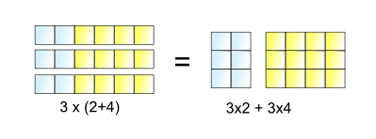
Teach the commutative law. A commutative operation is one in which the order of combining the two objects does not matter. (This can be taught within multiplication and addition).

a x b = b x a
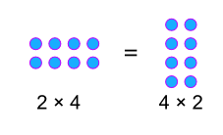

Tara Loughran multiplication games to practise fluency.

- Race Track Game
- Bump Multiply
- Choose Your Points
- Circle Targets
- Find the Calculation
- Inverse Circles
- Four in a Row – mixed
- Box My Counter

