Weekly attendance newsletter – Week 4 Autumn term 2 2022-2023
As a school, we aim for all children to have 95% or above attendance.
From September until this week, our overall school attendance is 92.2%
Last week, our overall school attendance was 91.1% (counting children at or above mandatory school age = 5).
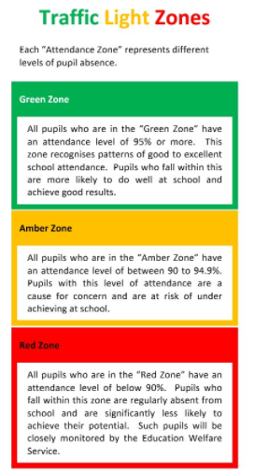
STRIVE FOR 95+%
The best place for your children to be every day is in school.
 | Last week | Two weeks ago
2-year-olds | 84.2% | 85.7%
F1 | 82.8% | 98.3%
F2 | 93.4% | 87.7%
Y1 | 95.8% | 89.6%
Y2 | 96.2% | 92.7%
Y3 | 88.8% | 80.8%
Y4 | 98.1% | 84.1%
Y5 | 89.2% | 85.4%
Y6 | 83.9% | 91.8%

