Weekly attendance newsletter – Week 1 Autumn term 2 2022-2023
As a school, we aim for all children to have 95% or above attendance.
From September until this week, our overall school attendance is 90.2%
Last week, our overall school attendance was 86.2% (counting children at or above mandatory school age = 5).
STRIVE FOR 95+%
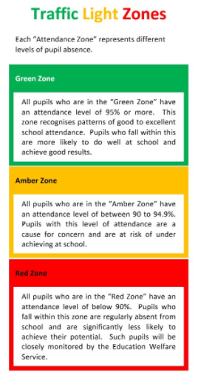
The best place for your children to be every day is in school.
 | Last week | Last week of Autumn term 1
2-year-olds | 80.5% | 90%
F1 | 80.6% | 88.1%
F2 | 83.7% | 83.7%
Y1 | 87.9% | 80.8%
Y2 | 91.5% | 85%
Y3 | 85.4% | 88.8%
Y4 | 80% | 94.4%
Y5 | 84.6% | 96.5%
Y6 | 90% | 90.7%

