Weekly attendance newsletter – Week 6 Spring term 1 2022-2023
As a school, we aim for all children to have 95% or above attendance.
From September until this week, our overall school attendance is 90.4%
Last week, our overall school attendance was 93.7% (counting children at or above mandatory school age = 5).
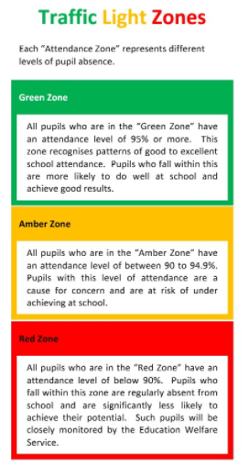
STRIVE FOR 95+%
The best place for your children to be every day is in school.
 | Last week | Two weeks ago
2-year-olds | 80% | 92.5%
F1 | 78.9% | 100%
F2 | 96.1% | 98.4%
Y1 | 92.5% | 86.5%
Y2 | 96.2% | 95.7%
Y3 | 97.1% | 92.7%
Y4 | 90% | 95.7%
Y5 | 90.4% | 90.1%
Y6 | 93.9% | 93.3%

