Weekly attendance newsletter – Week 4 Spring term 1 2022-2023
As a school, we aim for all children to have 95% or above attendance.
From September until this week, our overall school attendance is 90%
Last week, our overall school attendance was 93.3% (counting children at or above mandatory school age = 5).
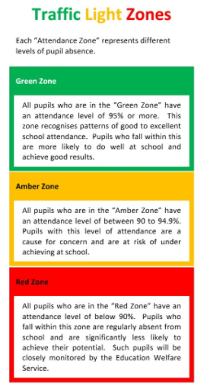
STRIVE FOR 95+%
The best place for your children to be every day is in school.
 | Last week | Two weeks ago
2-year-olds | 82.9% | 95.7%
F1 | 92.2% | 100%
F2 | 96.5% | 96.5%
Y1 | 91.7% | 95.8%
Y2 | 96.2% | 94.2%
Y3 | 96.3% | 87.2%
Y4 | 93.1% | 98.8%
Y5 | 92.9% | 92.9%
Y6 | 86.8% | 93.6%

