Helping your child

learn Maths at home

## What parents/adults can do to promote children’s enjoyment of maths:

* Adults can support and encourage mathematical vocabulary relating to number, shape and size.
* Adults can also support and encourage children to experiment with numbers shape and pattern that can develop their confidence.
* Children can be stretched further through questioning, e.g. How many can you find? How many less? What shape is it?
* They can be taken to an environment to observe shapes and patterns around them.

**In the street**

* Recognising bus numbers
* Number plate hunt. Who can find a 7? Add the numbers up.
* Comparing door numbers
* Counting – how many lampposts on the way to school?

**Doing the washing**

* Counting in 2s – matching shoes
* Sorting by colour and size.
* Matching/pairing up socks.
* Find four shoes that are different sizes. Can you put them in order.

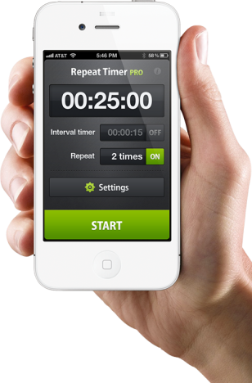**Time**

* What day is it yesterday, today, tomorrow?
* Use timers, phones and clocks to measure short periods of time.
* Count down 10/ 20 seconds to get to the table/ into bed etc.
* Recognising numbers on the clock. If you cover a number, what number was missing?

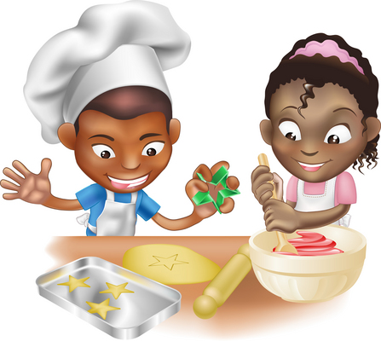**Food!**

* Can you cut your toast into 4 pieces? Can you cut it into triangles?
* Setting the table. Counting the right number of plates etc. How many more do we need? Who will sit next to? Who is on the right/left?
* Can you make shapes/ patterns out of the knives and forks. Can you put them in the right place in the drawers?
* Helping with the cooking by measuring and counting ingredients.
* Setting the timer.
* Positional language at dinner time: what is on the rice, where are the carrots etc?

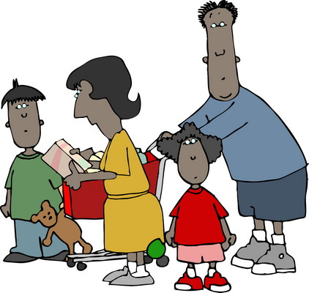

**Going shopping**

* Reading price tags
* Counting items into the basket
* Finding and counting coins
* Comparing weights – which is heavier
* Sorting foods into groups

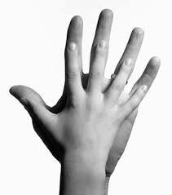**Measuring**

* Are you taller than a …?
* Marking height on the wall.
* Cut hand shapes out of paper. How many hands long is the couch? How long is the table? Which is longer?
* Who has the biggest hands in our family?
* How many steps from the gate to the front door?
* How many cups will it take to fill a saucepan? Guess first.
* How many glasses can you fill with one jug of water?

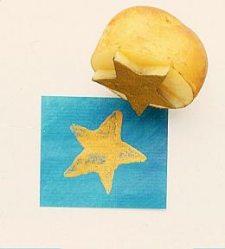**Shapes**

* Cut a potato into shapes (circles, triangle etc). Use with paint to make pictures and patterns.
* Cut out shapes from coloured paper/ newspaper and arrange into pictures.
* Shape hunt: Can you find a square in your house (windows etc), a circle …

**Playdough**

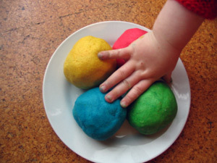Here’s a simple recipe:

***1 cup of plain flour***

***1 cup of water***

***1 tablespoon cooking oil***

***2 teaspoons cream of tartar***

***Half a cup of salt***

***food colouring and essences (optional)***

*Put all ingredients in a large saucepan, and heat slowly, stirring all the time until it forms a ball. Keep it wrapped in clingfilm or in a covered tub to stop it drying out.*

Then ….

* Make numerals and shapes
* Sort shapes into groups, or order by size
* Make long and short wiggly snakes.

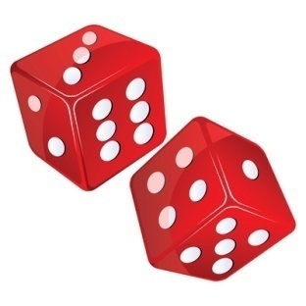**Games**

* Putting cards into piles
* Jigsaws (you can make your own by cutting up a magazine picture)
* Snap (matching pairs) or Happy Families (collect 4 of a kind)
* 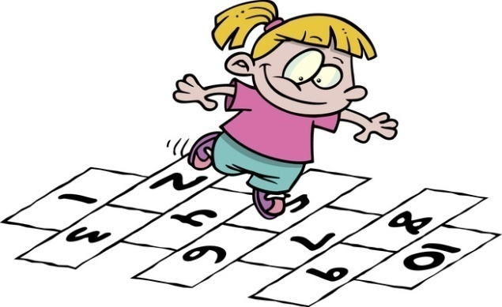Snakes and ladders or other simple dice games.
* Adding numbers on two dice.
* Bingo, with numbers or shapes
* Hopscotch

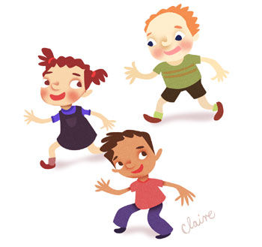

* What's The Time Mr Wolf?

Age: 4+

**How to play:**

One child stands apart with his back to the other children, who should be a good distance away. He or she is Mr Wolf.

The group calls out "What's The Time, Mr Wolf?"

He replies with a time - for example, ""It's 2 o'clock"

The group then takes 2 steps forward, towards Mr Wolf, and asks again, "What's The Time, Mr Wolf?"

This time he might say "It's 10 o'clock", in which case the group would take 10 steps forward.

The group is attempting to reach Mr Wolf without him first catching them. When Mr Wolf senses that somebody is close, he can call out, instead of a time like before, "It's Dinner Time!", at which point he can finally turn around and see where everybody is, then try to catch somebody before they can make it back to the starting line. There is usually much screaming and excitement at this point!

**Hints:**

Make sure everybody gets a turn to be Mr Wolf.

Children will tend to vary between those who take great big steps to try to reach Mr Wolf first, and those that take very small steps so that they can run back to safety when he calls Dinner Time!

A big space, such as a playground or park, is perfect.

It may be best if an adult is the first "Mr Wolf" to show the children how to play.

**Number rhymes and songs**

*Eg: 5 little monkeys jumping on the bed*

*One fell off and bumped his head*

*Mummy called the doctor and the doctor said*

*“No more monkeys jumping on the bed!”*

*4 little monkeys jumping on the bed …*

Your child can teach you lots more or try this website which has the words and sings it for you:

https://www.nurseryrhymes4u.com/NURSERY_RHYMES/counting.html

<https://www.youtube.com/watch?v=PDnXXgK-OXI>

**Internet maths games:**

www.mathszone.co.uk

http://www.bbc.co.uk/bitesize/ks1/maths/

http://www.familylearning.org.uk/online_math_games.html

[www.sesamestreet.org](http://www.sesamestreet.org)

<http://tpet.co.uk/mrwolf/playfree.html>

**Maths Games at Home**

Videos with great ideas for games to play with children at home.

<https://www.oxfordowl.co.uk/for-home/maths-owl/expert-help--2/fun-maths-at-home>