Key stage 2 - English grammar, punctuation and spelling practice paper

First name
Middle name
Last name
Date of birth | Day | Month | Year
School name

Instructions

This paper has different types of questions for you to answer in different ways. The space for your answer shows what type of answer is needed. Write your answer in the space provided.

Some questions are multiple-choice. You do not need to do any writing but you will need to read the question carefully so you know how to answer each question.

The number under each line at the side of the page tells you how many marks you will get for the right answer.

Work through the booklet until you are asked to stop. If you finish before the end, go back and check your answers.

You have 45 minutes to complete this test.
- Which sentence uses capital letters correctly?
Tick one
Tom and Zaib went to london on saturday.
tom and zaib went to london on Saturday.
Tom and Zaib went to London on saturday.
Tom and Zaib went to London on Saturday.
1 mark

- Which sentence is a command?
Tick one
Turn the light off.
Have you turned the light off?
I must turn the light off.
I’ve already turned the light off.
1 mark
- Circle the adverb in this sentence.
As she walked to school, Lucy tripped and fell heavily. 1 mark

- Circle the sentence that needs a question mark.

We’re going to the park later
Are we going to the park later
Go to the park
I want to go to the park
1 mark

- Re-write the sentence below in the past tense.
Amal and Harry are having lunch and then going to the cinema.

1 mark
- Choose the correct conjunction to complete the sentence.
because | but | for
You may bring sweets on the trip not chocolate.
1 mark

- Insert a pair of commas in the correct place in the sentence below.
Olivia a kind and helpful girl helped her friend tidy her bedroom.
1 mark

- Circle all the antonyms in the sentence below.
The old house was ugly from the outside but inside was really quite beautiful.
1 mark

- Which of these sentences is written in the passive voice?
Tick one
The boy smashed the window with his football.
The football crashed through the window.
The window was smashed by the football.
The boy crashed through the window with his football.
1 mark

- Insert a comma in the sentence below to make it clear that only Mohammed and Charlie played on the tablet.
Having left Jack Mohammed and Charlie played on the tablet.
1 mark
- Circle the adjectives in the sentence below.
The picnic was delicious. The drinks were cold and the strawberries sweet.
1 mark

- Label each word with the correct letter.
A  noun |  | B  verb |  | C  adjective |  | D  adverb |  | E  determiner |  |  | F  preposition
The | black |  | cat |  | stretched |  | lazily |  | across | the |  | rug
1 mark

- Complete the sentence with the simple past tense of the verbs below the spaces.

I to the cinema last weekend, but I the beginning of the film as

to go to miss
we stuck in traffic.

to be
1 mark
- Which of these words is a preposition?
 | Tick one
and
between
because
the |  | 1 mark
- Circle the subject of the sentence below.
The teacher asked the class to be quiet.
1 mark
- Which of these sentences is punctuated correctly?
Tick one.
Although Joe loved football – he didn’t play very often.
Although Joe loved football; he didn’t play very often.
Although Joe loved football, he didn’t play very often.
Although Joe loved football he didn’t play very often.
1 mark
- Complete the sentence with an appropriate subordinating conjunction.
We were home late from the school trip the coach broke down.
1 mark
- Which of these sentences is a statement?
 | Tick one.
Be quiet
Would you close the door
It’s quieter when the door is closed
Close the door |  | 1 mark
- Which sentence uses the present progressive tense?
 | Tick one.
Finn is having guitar lessons.
Finn used to have guitar lessons.
Finn has guitar lessons.
Finn had guitar lessons. |  | 1 mark

- Insert brackets in the correct places in the sentence below.
Jamal’s brother who was younger than him could be annoying.
1 mark
- Insert a semi-colon in the correct place in the sentence below.
I’m looking forward to our holiday we are going next week.
1 mark
- Circle the conjunctions in the sentence below.
The wind was strong but the tree stayed standing and everyone stayed safe.
1 mark
- Underline the subordinate clause in the sentence below.
I love dancing, although I don’t have great rhythm.
1 mark

- Write a sentence using the word book as a verb. Do not change the word. Remember to punctuate your sentence correctly.

1 mark
- Write a sentence using the word book as a noun. Do not change the word. Remember to punctuate your sentence correctly.

1 mark
- Which prefix can be added to all three words below to make their antonyms? Write the prefix in the box.
understand
behave
read
1 mark

- Circle the two words that are synonyms in the sentence below.
He was waiting for an answer but the reply was a long time coming.
1 mark
- Circle the possessive pronoun in the passage below.
The baby cried. She wanted her mother.
1 mark
- Which of these is an exclamation?
 | Tick one.
You’ve done well
I’m pleased you’ve done well
Did you do well
Well done |  | 1 mark
- Circle the relative pronoun in the sentence below.
The sun, which had risen at 5am, was high in the sky.
1 mark
- Complete the sentence below with an adjective formed from the word thought.
He really was a boy.
1 mark
- Which of these sentences is punctuated correctly?
 | Tick one.
“That was brilliant”! Said the teacher.
“That was brilliant!” said the teacher.
That was brilliant said the teacher.
“That was brilliant said the teacher!” |  | 1 mark

- Circle the modal verb in the sentence below.
I could see my sister was upset so I gave her a cuddle.
1 mark

- Which of these plural possessive apostrophe sentences is punctuated correctly?
 | Tick one.
The boys paintings were displayed in the hall.
The boy’s paintings were displayed in the hall.
The boys painting’s were displayed in the hall.
The boys’ paintings were displayed in the hall. |  | 1 mark

- Which of these sentences uses a colon correctly? Tick one.
 | Tick one.
There was lots of food pizza: crisps, cake and biscuits.
There was lots of food: pizza, crisps, cake and biscuits.
There was: lots of food pizza crisps, cake and biscuits.
There was lots of food pizza: crisps: cake: and biscuits. |  | 1 mark

- Which of these sentences is written in Standard English?
 | Tick one.
I been to the skate park a few times.
I done really well.
There was loads of people there.
I went to the skate park last week. |  | 1 mark

- Place a possessive apostrophe in the correct place in the sentence below.
Katies dad drove her to the party.
1 mark

- Complete each sentence below with the correct possessive pronoun.
The kitten belongs to us. The kitten is
That ball belongs to me. The ball is
That phone belongs to my brother. That phone is
1 mark

- What are the expanded forms of the words below?
I’ll
I won’t
I can’t
1 mark

- Tick the box to show which clause is underlined in the following sentences.
Sentence | Main  clause | Subordinate  clause
Chloe always takes an umbrella, even when it’s not raining.
If he ran fast, he would catch them.
Although it was late, Sally didn’t feel tired.
1 mark

- Re-write the sentence below in the active voice.
The winner was announced by the reigning champion.

1 mark
- Complete these sentences with an appropriate determiner.
We saw rainbow this morning.
Once rain started, we had to go inside.
My favourite fruit is orange.
1 mark
- Circle the object in the sentence below.
I bought some jeans in the sale.
1 mark
- Which verb form completes this sentence?
Once I my homework, I watched the television.
 | Tick one.
am finishing
finish
have finished
had finished |  | 1 mark

- What is the correct word class of the underlined words in the sentence below?
The children watched as a keeper showed how to feed an otter.
 | Tick one.
adverbs
pronouns
determiners
prepositions |  | 1 mark

- Re-write this sentence putting capital letters in the correct places.
mum, william and i visited france and spain last august.

1 mark
- Replace the underlined words with the correct pronouns.
On Tuesday, Aisha visited her cousins and her cousins gave Aisha some sweets.
1 mark

- Insert full stops and capital letters to punctuate the passage below correctly.
jamie was looking forward to starting secondary school his older brother was already there
and loved it he was particularly looking forward to playing hockey
1 mark
- Complete these sentences with the correct punctuation mark.
It’s really hot
Can I play
I’m going shopping in a minute
1 mark
- Underline the prepositions in the sentence below.
The dog lay between her feet and wagged its tail against the floor.
1 mark

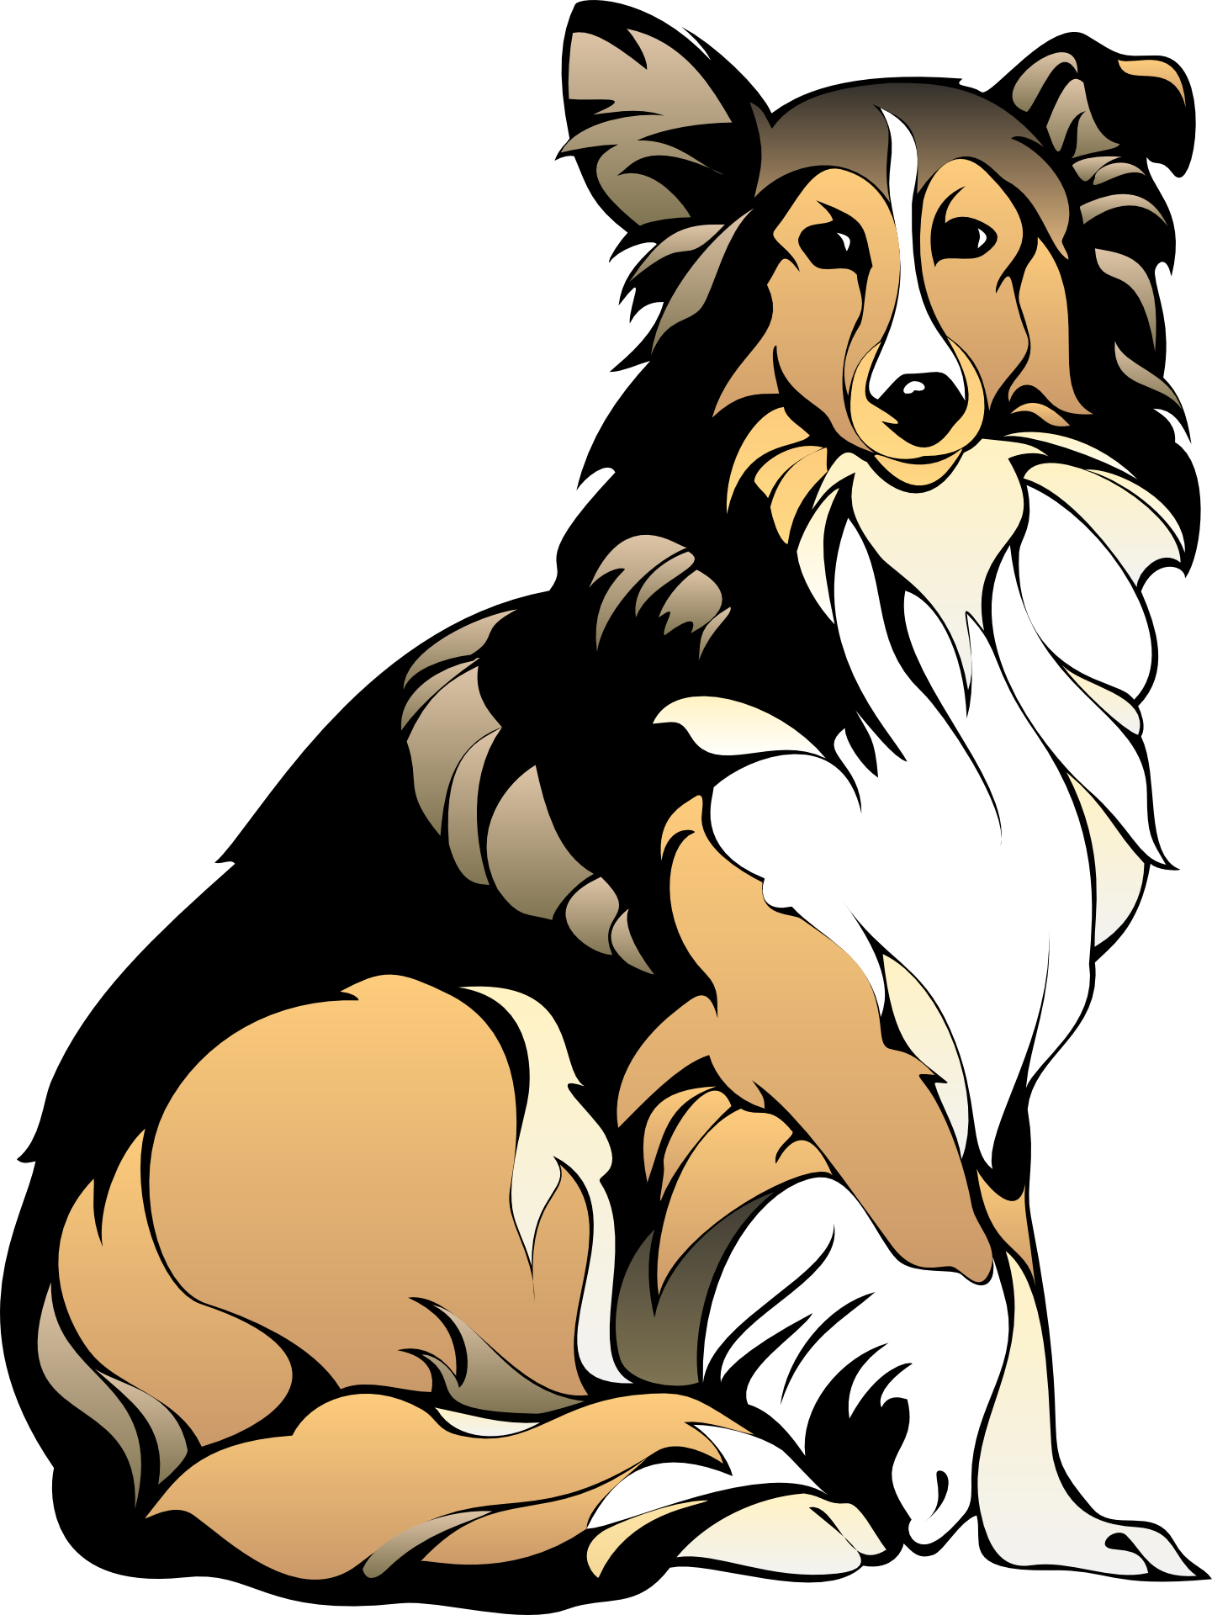
Answers

Question | Answer |  | Mark
1 | Tom and Zaib went to London on Saturday. |  | 1
2 | Turn the light off. |  | 1
3 | As she walked to school, Lucy tripped and fell heavily. |  | 1
4 | Are we going to the park later |  | 1
5 | Amal and Harry had lunch and then went to the cinema. |  | 1
6 | You may bring sweets on the trip but not chocolate. |  | 1
7 | Olivia, a kind and helpful girl, helped her friend tidy her bedroom. |  | 1
8 | The old house was ugly from the outside but inside was really quite beautiful. |  | 1
9 | The window was smashed by the football. |  | 1
10 | Having left Jack, Mohammed and Charlie played on the tablet. |  | 1

11 | The picnic was delicious. The drinks were cold and the strawberries sweet. |  |  |  |  |  |  |  |  | 1
 | The | black | cat | stretched | lazily | across |  | the | rug | 1
 | E | C | A | B | D | F |  | E | A
13 | I went to the cinema last weekend, but I missed the beginning of the film as we were stuck in traffic. |  |  |  |  |  |  |  |  | 1
14 | between |  |  |  |  |  |  |  |  | 1
15 | The teacher asked the class to be quiet. |  |  |  |  |  |  |  |  | 1
16 | Although Joe loved football, he didn’t play very often |  |  |  |  |  |  |  |  | 1
17 | We were home late from the school trip because the coach broke down. |  |  |  |  |  |  |  |  | 1
18 | It’s quieter when the door is closed |  |  |  |  |  |  |  |  | 1
19 | Finn is having guitar lessons. |  |  |  |  |  |  |  |  | 1

20 | Jamal’s brother (who was younger than him) could be annoying. |  |  | 1
21 | I’m looking forward to our holiday; we are going next week. |  |  | 1
22 | The wind was strong but the tree stayed standing and everyone stayed safe. |  |  | 1
23 | I love dancing, although I don’t have great rhythm. |  |  | 1
24 | Award 1 mark for a grammatically correct sentence that uses book as a verb and that is correctly punctuated, e.g.  I’d like to book tickets for the cinema. |  |  | 1
25 | Award 1 mark for a grammatically correct sentence that uses book as a noun and that is correctly punctuated, e.g.  She opened the book and began to read. |  |  | 1
26 | mis |  |  | 1
27 | He was waiting for an answer but the reply was a long time coming. |  |  | 1
28 | The baby cried. She wanted her mother. |  |  | 1
29 | Well done |  |  | 1
30 | The sun, which had risen at 5am, was high in the sky. |  |  | 1
31 | He really was a thoughtful boy. |  |  | 1
32 | “That was brilliant!” said the teacher. |  |  | 1
33 | I could see my sister was upset so I gave her a cuddle. |  |  | 1
34 | The boys’ paintings were displayed in the hall. |  |  | 1

35 | There was lots of food: pizza, crisps, cake and biscuits. |  | 1
36 | I went to the skate park last week. |  | 1
37 | Katie’s dad drove her to the party. |  | 1
38 | The kitten belongs to us. The kitten is ours.  That ball belongs to me. The ball is mine.  That phone belongs to my brother. That phone is his. |  | 1
39 | I will  I will not  I cannot or I can not |  | 1
40 | Sentence Main clause Subordinate clause  Chloe always takes an umbrella, even when it’s not raining.  If he ran fast, he would catch them.  Although it was late, Sally didn’t feel tired. |  | 1
41 | The reigning champion announced the winner. |  | 1
42 | We saw a rainbow this morning.  Once the rain started, we had to go inside.  My favourite fruit is an orange. |  | 1

43 | I bought some jeans in the sale.  You may also accept:  I bought some jeans in the sale. |  |  |  |  |  | 1
44 | had finished |  |  |  |  |  | 1
45 | determiners |  |  |  |  |  | 1
46 | Mum, William and I visited France and Spain last August. |  |  |  |  |  | 1
47 |  |  |  |  |  |  | 1
 |  | they |  | her
48 | Jamie was looking forward to starting secondary school. His older brother was already there and loved it. He was particularly looking forward to playing hockey. |  |  |  |  |  | 1
49 | It’s really hot!  Can I play?  I’m going shopping in a minute. |  |  |  |  |  | 1
50 | The dog lay between her feet and wagged its tail against the floor. |  |  |  |  |  | 1

