Weekly attendance newsletter – Week 3 Spring Term 2 2022-2023
As a school, we aim for all children to have 100% attendance.
From September until this week, our overall school attendance is 90%
Last week, our overall school attendance was 90.2 % (counting children at or above mandatory school age = 5).
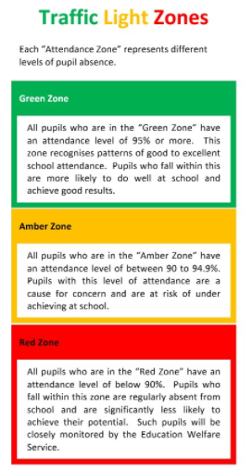
STRIVE FOR 100%
The best place for your children to be every day is in school.
 | Last week | Two weeks ago
2-year-olds | 82.1% | 95.2%
F1 | 85.5% | 93%
F2 | 78.7% | 92%
Y1 | 92.1% | 93.8%
Y2 | 95.5% | 93.3%
Y3 | 87.5% | 92.4%
Y4 | 92% | 94%
Y5 | 93.2% | 89.6%
Y6 | 92.4% | 94%

