Weekly attendance newsletter – Week 5 Autumn term 1 2022-2023
As a school, we aim for all children to have 95% or above attendance.
From September until this week, our overall school attendance is 91.1%
Last week, our overall school attendance was 86.3% (counting children at or above mandatory school age = 5).
STRIVE FOR 95+%
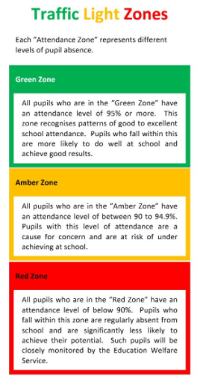
The best place for your children to be every day is in school.
 | Last week | 2 weeks ago
2-year-olds | 81.3 | 88.0
F1 | 86.2 | 98.5
F2 | 89.3 | 87.0
Y1 | 88.8 | 96.3
Y2 | 78.5 | 94.6
Y3 | 82.7 | 92.7
Y4 | 95.2 | 86.7
Y5 | 87.8 | 87.4
Y6 | 84.3 | 86.1

